28 October 2011
Robert Morin
Secretary General
CRTC
Ottawa, ON
K1A 0N2

Dear Mr. Secretary General,

Re: Broadcasting Notice of Consultation CRTC 2011-488, Call for comments on proposed English-language Closed Captioning Quality Standards, 15 August 2011.

Media Access Canada (MAC) is pleased to submit the attached comments in response to the proceeding noted above.

MAC requests the opportunity to appear before the Commission to address issues raised by in this document. Further, if you have any questions, please do not hesitate to contact the undersigned.

Sincerely yours,
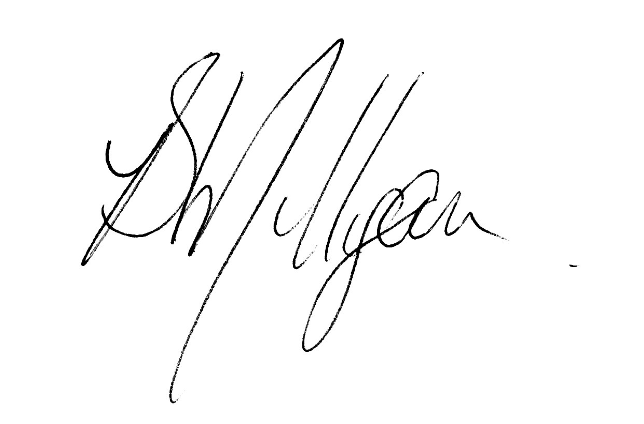
Beverley Milligan
CEO

c.c. Access 2020 Coalition

1. Executive Summary

- Media Access Canada, MAC, is an independent, not-for-profit organization established to secure and administer an Accessibility Fund that would provide seed funding for tangible projects to support innovation that provides platform-neutral solutions to ensure accessibility of all broadcasting content, thereby removing barriers and leading to a 100% accessible content Canadian broadcast day across all regulated and unregulated distribution platforms.
- MAC is recognized internationally for its work in closed captioning (CC) and descriptive video (DV) best practice and standards development. MAC has been a vocal advocate on the part of the Access 2020 Coalition for the cause of a 100% fully accessible broadcast day and the establishment of a Broadcasting Accessibility Fund to bring this about.
- MAC supports the movement toward empowering the Accessibility Community to develop standards and best practices as a fundamental step toward achieving 100% accessibility across all distribution platforms.
- We begin our comments by defining the Accessibility Community and highlighting the challenges of defining what constitutes an error in the context of closed captioning.
- We then quickly address the questions raised by the Commission.
- Finally, we conclude by suggesting a new approach to the creation and ongoing updates for CC standards and best practices development.
- MAC thanks the Commission for its demonstrated commitment to ensuring a standard of quality for accessible content, in this case for Closed Captioning. We also thank the Commission for allowing us to participate in the standards development process, as we have to date not been permitted by CAB, the gatekeeper of record thus far, to do so. We are available to provide further detail on the issues discussed in this document.
2. The Accessibility Community
- The Accessibility Community is made up of those organizations of and for persons with disabilities but excluding those organizations whose primary revenue model is fee-based services.
- The primary users of CC and DV are blind and low vision, deaf and hard of hearing Canadians and therefore, it is the many organisations representing these individuals who constitute the Accessibility Community in the context of this discussion.
- For the purposes of this submission, we define the Closed Captioning Accessibility Community as The Canadian Hard of Hearing Association (CHHA), The Canadian Association of the Deaf( CAD), The Canadian Hearing Society( CHS), The Ontario Association of the Deaf (OAD) and other provincial organizations, the Bob Rumball Centre for the Deaf (BRCD) and many more.
- MAC, with a board that is a minimum of 2/3 Accessibility Community would fall within the definition and be considered independent and objective experts in accessible media in Canadian Communications.
- We note the CAB chose to invite only representatives from CHHA and CAD to participate on their working group.
3. Definition of an Error
- Measuring the captioning accuracy/errors in television programming is very difficult, which is why the definition of an “error” is also difficult. From a user’s perspective, an error is incorrect spelling, garbled captions, cut-off captions, dropped captions or any other flaw that detracts from the ability to understand or enjoy the broadcast.
- For a BDU, the definition of an error would be more technical in nature, something that caused an interruption to the encoded captioning broadcast feed.
- A real-time captionist measures accuracy, not errors.
“The steno/captioning software measures accuracy based on untranslates, not missed words. It does this by counting anything it didn’t recognize in a person’s English dictionary, so it would count trustss (two ss) as an error even though you know what it is. It would count an untranslate that actually translated right but showed up as an untranslate because it wasn’t in someone’s dictionary. By the same token, if a word is in the dictionary but didn’t belong in the sentence, it would not be counted as a mistake because the software would not know it was in the wrong place.”

- A broadcaster can only be held responsible for that over which they have control, for example encoding and who they contract with for captioning services.
- Ultimately, an error is the culmination of events that lead to a negative user experience. This negative user experience includes: the inability to comprehend the media being viewed; the inability to experience the media in a way that is equivalent to a user whose access does not require assistive technology; and the inability to experience the entire piece in a seamless uninterrupted manner.
- This definition, however, does not allow us to identify cause.
- Therefore, to understand errors in a specific context it would be helpful to move beyond a definition and develop a matrix of where errors originate and to look at best practice solutions. Table 1 below highlights a matrix of cause.

Table 1. Example of matrix for error definition

Captioning Approach | Content Producer | Broadcaster | Distribution | User Interface
Live – Roll-up:  Stenographer/live audio feed | Untranslates  Lag  Caption placement | Encoding  Caption placement  Audio feed  Simulcast | Upconversion  Lag | CC enabled
Post Production:  Roll-up  Pop-on | Synchronization  Spelling | Transcoding  Simulcast | Upconversion | CC enabled

- A broad definition of error will consider the user experience in its entirety, but also identify symptom and cause. It is not, therefore, a simple matter of user preference. Every step of the creation and distribution system must be analysed as a potential source of error. The measure of error will depend on the stage being assessed: for a captionist, the relevant measure is accuracy rate: for broadcasters, it is ensuring the quality of the captionists and production houses with which they work; and for BDUs it is ensuring the broadcast feed gets safely to the home intact.
4. Live Steno Captioning and Live Voice Recognition.
- The National Court Reporter’s Association has a certification system for voice and steno methodologies for translation that any captionist must, at a minimum, should have before they are qualified to perform live on-air. This is an immediate solution until such time as the necessary captioning-specific requirements can be developed which will encompass placement, correction and other issues.
- It is important to note that in the absence of best practices framework for the licence renewal reporting for compliance, monitoring, measurement and reporting standards, at a minimum the live captionist has the ability to provide to the broadcaster, immediately following the program that was captioned, a rate of words per minute and a percentage accuracy measure. This information should be provided to an independent monitoring body, on an ongoing basis, so that yearly reports can be prepared for the Commission, Industry and key stakeholders.
- It is also important to note that this certification requires an accuracy rate of 96% at 180 words per minute. While the CC Accessibility Community should be respected in their requirement of 98%, at a minimum, any policy should be, at a minimum, consistent with the organization established to represent the interests of steno and voice transcribers.
- We acknowledge that the French Working group agreed to an 85% error rate and wonder if they were provided with the necessary information to then make decisions based on fact, as we understand this basic information was not provided to the English group.
- A properly funded Accessibility Community-led working group would ensure the necessary independent expertise to avoid these unnecessary delays in standards development.
- Remainder of questions notably:
“a) the appropriateness of the standards on which the EN-CCWG reached consensus;
b) the extent to which the standards proposed by the FL-CCWG for the following areas should be included in the English-language standards:
• captions that block other on-screen information
• lag time for live programming
• correction of errors in re-broadcast of live programming
• sign-language interpretation in emergency messages
c) the appropriateness of distinguishing between mandatory standards and guidelines for best practices;
d) whether additional standards are needed;

e) for Canadian pre-recorded programming, why the wording set out in the Commission’s July 30, 2010 letter regarding the type of programming that must be provided in pop-on captions would not be an appropriate standard for the English-language market; and
f) whether further action is required for the following:
• to develop concrete, workable solutions with respect to other outstanding captioning quality issues, including the reduction of errors and technical problems such as dropped or garbled captioning, or captioning that is cut off by commercials;
• to address captioning issues in a digital environment as discussed in paragraph 55 above.”

- Given that captioning exists first and foremost for the benefit of the deaf and hard of hearing, their view must be adopted in the absence of strong evidence to the contrary. For this reason, MAC encourages the CRTC to consider the submission filed by CHHA and CAD.
- It was difficult to understand why the CAB chose so few CC Accessibility Community participants when the CRTC directed them to do this important work. In CRTC 2009-430 the commission required the broadcasters:
“1. ….The Commission also directed the broadcasting industry to establish two closed captioning working groups (CCWGs), one for the French-language television market (FL-CCWG) and one for the English-language television market (EN-CCWG).
2. The Canadian Association of Broadcasters (CAB), on behalf of the broadcasting industry, coordinated the establishment of both CCWGs.”
- The CAB was given all of the control to establish the working groups and had an opportunity on two separate occasions to invite more experts, users and stakeholders to participate. In fact, the CRTC, in 2009-430, required them to do so. Instead, the CAB chose to invite a limited number of users, when many organizations and experts asked to participate. The CAB was in control of who got to participate and then chose not to address their concerns.
- We wonder why the CAB would choose to do this, as it would only further delay the implementation of any standard or best practice.
- While we understand the challenges involved in the conflicting agendas of the broadcaster and the Accessibility Community, without evidence to support the broadcaster position, we respectfully suggest that the Accessibility Community’s position must be implemented as the standard and form the starting point for future work in this area.
- We arrive at this position because it was CAB who had the funding, the directive and the evidence, which led the Accessibility Community to its current position.
- MAC wonders why the CAB would cause such delays – years of discussion and two formal attempts from CRTC directives that were not fully complied with.
- We can only conclude the current CRTC direction, which has the broadcasters paying themselves to deliver a product, is not working.
- We respectfully submit it is time for a change of direction.
5. Conclusion
- The commission asked, “if further action (was) proposed, whether the mandate of the working group should be extended for these purposes or if an alternative approach should be adopted”
- Consistent with the historical fact that the Accessibility Community has moved the captioning agenda forward, both in standards and best practices development, as well as business innovation, etc. We ask that the CRTC direct the Accessibility Community to continue the Standards and Best Practices work.
- While broadcasters and BDUs must participate and collaborate with the Accessibility Community, a more successful approach might be the one that MAC uses in its best practices working groups:
  - Open source
  - Invite key stakeholders but anyone can participate; sub-committee creation for key issues
  - Research and education to support committee members
  - Publish and update on-line regularly
- We need a fundamental shift in accessible content best practices, standards and policy development and the Commission can do this by requiring the broadcasters to collaborate in an Accessible Community-led initiative to continue the development of best practices updates and standards development review.
- We thank the Commission for allowing us to participate in the standards development process and are available to respond to questions or to provide further detail on the issues discussed in this document.

MAC recently published on-line, an open source Descriptive Video Production and Presentation Best Practices Guide for Digital Environments.
, Owner, National Captioning Canada
Table is incomplete and to be used for example purposes only
<http://ncraonline.org/certification/Certification/crr/default.htm
CRTC 2011-488
CRTC Public Notice 2011-488
CRTC 2009-430, 80
LOBCO Inc created the original best practices manual for closed captioning and MAC created the first ever open source DV Production and Presentation Best Practices Guide for Digital Environments.

