August 23, 2010 Via electronic submission

Mr. Robert A. Morin
Secretary General
CRTC
Ottawa, ON
K1A 0N2

Dear Mr. Secretary General,

Re: CRTC, Items 1 & 2, Broadcasting Notice of Consultation CRTC 2010-498, (Ottawa, 22 July 2010)
Media Access Canada (MAC) is pleased to submit the attached intervention in response to Item 2 in the proceeding noted above. A copy of the intervention has been e-mailed to Ms. Rathwell at Shaw.
MAC requests the opportunity to appear before the Commission in Calgary to address issues raised by the applicant in this proceeding, and requests sign language interpretation. We will contact you within the specified time frame if we require video conferencing. If you have any questions, please do not hesitate to contact the undersigned.
Sincerely yours,

Beverley Milligan

c. Cynthia Rathwell, cynthia.rathwell@shawdirect.ca
Shaw Communications Inc., on behalf of
CanWest Global Communications Corp.
630 – 3rd Avenue South West
Suite 900
Calgary, Alberta
T4P 1L4
Fax: 403-716-6544

Canadians with disabilities in 2006:
4,417,870

Shaw’s cash on hand on August 31, 2009:
$ 253,862,000

Shaw’s commitment to accessibility on Canwest stations over the next five years?:
$ 0

Ten suggestions for doing more
Intervention by
MEDIAACCESSCANADA

With respect to
Broadcasting Notice of Consultation CRTC 2010-498,
Items 1 & 2

23 August 2010
Contents

Executive Summary 1
I Introduction 1
II Media, accessibility and the law 2
A Legislation regarding accessibility 4
B Role of the CRTC 6
C Accessibility in broadcasting 8
III Shaw’s Application 13
A Shaw’s circumstances 13
B Shaw and accessibility 16
C Shaw’s accessibility benefits 18
IV Media Access Canada’s Conclusion and Recommendations 24
Recommendation 1: The CRTC should report on levels of original and repeat closed captioned and described video programming broadcast by Canwest stations by station and broadcast year since 2000 27
Recommendation 2: The CRTC should report on Canwest’s expenditures on closed captioning and descriptive video since 2000 27
Recommendation 3: The CRTC must set minimum levels of closed-captioned and descriptive video content by condition of licence, with the understanding that these levels will be reassessed in 2011 27
Recommendation 4: The CRTC must require that Shaw’s Canadian content complies with industry standards for accessible content. 27
Recommendation 5: The CRTC must establish that minimum levels of accessible content in its programming content (whether over-the-air, by satellite or online) will increase over time, regardless of the financial circumstances of the licensee or its licensed undertakings 27
Recommendation 6: A portion of the benefits from this transaction should be invested in technology to reduce accessible content production costs, and to ensure the availability of after-market access devices. 27
Recommendation 7: The CRTC should require that part of the benefits of this transaction establish an Education Envelope to expand markets for accessible content and ensure that people with disabilities are aware of the availability of accessible content 27
Recommendation 8: The CRTC should require Shaw to participate in the development of harmonized industry standards for accessible content that would consolidate closed captioning and descriptive video production and distribution, as well as multiple platform distribution, across Canada’s communications system (whether regulated, exempted or forborne) 28
Recommendation 9: The CRTC should require Shaw to contribute to the funding of an arms-length compliance measurement body that would take random samples of programming to report on the achievement of accessible content requirements across Canada’s communications system 28
Recommendation 10: The CRTC should require Shaw to contribute to the establishment of a central clearing house for archiving and distributing accessible content to the domestic and international communciations systems. 28

(Source of the figures on page 1:
Shaw Communications Inc., 2009 Annual Report, at 57 “Consolidated Balance Sheets”, “Cash and cash equivalents”;
Statistics Canada, “Persons with disabilities, by age group and sex (2006)” <http://www40.statcan.gc.ca/l01/cst01/health71a-eng.htm>.)

Executive Summary
- Media Access Canada, MAC is a not-for-profit organization with a mandate to increase the quantity and quality of accessible content in Canadian Broadcasting, by providing empirical research on accessible content, participating in national and international standards development committees and offering education about the benefits of a 100% accessible broadcast day across all media distribution platforms.
- We are joined in this intervention by a number of organizations and individuals advocating for accessible programming, set out on page 1 of the intervention.
- We are intervening to raise grave concerns about the application of Shaw Communications Inc., a large and profitable communications company, to acquire one of this country’s largest television broadcasters, Canwest, for approximately $2 billion.
- Canada’s highest court has long held that freedom of expression in the media is critical to Canadian democracy, because this freedom yields a competitive marketplace of ideas. Until the early 1980s, however, Canadians with disabilities were unable to access this marketplace. Constitutional protection of the rights of Canadians with disabilities having been formalized in 1982 under the Canadian Charter of Rights and Freedoms, the first steps towards accessible television programming content were made in the mid-1980s with closed captioning. Since then, the hourly costs of accessible content have fallen by half or more, and the Canwest television stations are now required to offer closed-captioned programming over the entire broadcast day.
- In 2009, the CRTC noted that the demand for accessible content that now exists will increase. The CRTC also determined that while more than four million Canadians report having a disability, their needs for accessible television programming content are unlikely to be met through the competitive marketplace. Shaw participated in this proceeding, and we welcomed its statement that it was “dedicated to providing all our customers with access to the best choice, value and quality of services. Responding to the unique needs and demands of our customers with disabilities has always been very important to us ….”
- Given Shaw’s clear commitment to accessibility, we are puzzled and disappointed that Shaw’s application does not refer to the needs and interests of hearing- and visually-impaired Canadians, does not explain whether the programming services it wants to acquire meet current accessibility requirements, does not make any commitments about its plans for the exhibition of and expenditure on accessible content, and has offered no tangible benefits with respect to improving the accessibility of programming content on the Canwest programming services or throughout the broadcasting system.
- Regretfully, therefore, we cannot support Shaw’s application unless substantive changes are made to ensure that the interests of Canadians who are visually- or hearing-impaired are addressed.
- We rely on the CRTC to protect the rights, needs and interests of all Canadians, including the 14% of the population who have disabilities, and who cannot rely on the competitive marketplace to serve their interests.
- We respectfully submit that the CRTC must address the lack of information about accessibility in Shaw’s application.
- We respectfully submit that because the CRTC must ensure that all Canadians benefit from this transaction – including those with disabilities – the CRTC cannot approve Shaw’s application as it has been presented to Canadians because Shaw
- has provided no information about current levels of accessibility,
- has made no commitments about accessibility exhibition and expenditure levels, and because
- its $203 million worth of ‘tangible’ benefits ignore accessibility, and the needs of more than four million people, entirely.
- We respectfully submit that a company of Shaw’s stature, could and should have a leadership role in accessible programming – especially if it seeks to demonstrate its commitment to Canada’s broadcasting system and Parliament’s broadcasting policy.
- We have ten recommendations that would make approval of Shaw’s application acceptable, and that would strengthen the accessibility of Canada’s communications system for Canadians:
Recommendation 1: The CRTC should report on levels of original and repeat closed captioned and described video programming broadcast by Canwest stations by station and broadcast year since 2000
Recommendation 2: The CRTC should report on Canwest’s expenditures on closed captioning and descriptive video since 2000
Recommendation 3: The CRTC must set minimum levels of closed-captioned and descriptive video content by condition of licence, with the understanding that these levels will be reassessed in 2011
Recommendation 4: The CRTC must require that Shaw’s Canadian content complies with industry standards for accessible content.
Recommendation 5: The CRTC must establish that minimum levels of accessible content will increase over time, regardless of the financial circumstances of the licensee or its licensed undertakings
Recommendation 6: A portion of the benefits from this transaction should be invested in technology to reduce accessible content production costs.
Recommendation 7: The CRTC should require that part of the benefits of this transaction establish an Education Envelope to expand markets for accessible content and ensure that people with disabilities are aware of the availability of accessible content
Recommendation 8: The CRTC should require Shaw to participate in the development of harmonized industry standards for accessible content that would consolidate closed captioning and descriptive video production and distribution, as well as multiple platform distribution, across Canada’s communications system (whether regulated, exempted or forborne)
Recommendation 9: The CRTC should require Shaw to contribute to the funding of an arms-length compliance measurement body that would take random samples of programming to report on the achievement of accessible content requirements across Canada’s communications system
Recommendation 10: The CRTC should require Shaw to contribute to the establishment of a central clearing house for archiving and distributing accessible content to the domestic and international communications systems.
- The recommendations above do not address specific exhibition and expenditure levels for closed captioning. This is because we have assumed that if the CRTC grants Shaw’s application and amends the Canwest licences to reflect Shaw’s control, the CRTC will still consider longer-term renewals of the programming services in 2011. We therefore believe that would be the appropriate time to consider and impose specific levels of accessible content conditions of licence.
- We have requested the opportunity to appear before the Commission at its Calgary public hearing, to address Shaw’s response to this intervention.

Introduction
- Media Access Canada, MAC is a not-for-profit organization with a mandate to increase the quantity and quality of accessible content in Canadian Broadcasting. To do this, MAC works with all industry stakeholders to provide empirical research on accessible content, organizes, chairs and participates in national and international standards development committees and working groups, and educates Canadians about the benefits of a 100% accessible broadcast day across all media distribution platforms.
- We are joined in this intervention by a number of organizations and individuals advocating for or producing accessible programming, including
Alliance for Equality of Blind Canadians
Bob Rumball Centre for the Deaf
Canadian Abilities Foundation
Canadian Council on Disabilities
Canadian Hard of Hearing Association
Canadian Hearing Society
Canadian National Institute for the Blind
Geoff Eden
Professor D. Fells, B.A.Sc., M.H.Sc., PhD., P.Eng. at the Ted Rogers School of Information Technology Management, Ryerson University
Inclusive Design Resource Centre (formerly the Adaptive Technology Resource Centre)
Dr. Charles Laszlo, P.Eng, O.B.C, University of British Columbia
Mary Frances Laughton (Librarian and Archivist’s Advisory Council on Access to Information)
March of Dimes
Neil Squire Foundation
Geoff Owen
Keith Parsonage
Sir Arthur Pearson War Blinded
Jim Sanders (C.M. Past President and Special Advisor, CNIB)
Katika Stark (past Chair, NBRS)

- We are intervening to raise grave concerns about the application of Shaw Communications Inc., one of Canada’s largest communications companies, to acquire one of this country’s largest television broadcasters, Canwest.
- We understand that Shaw reached an agreement to acquire control of Canwest in early February 2010, filed its application to acquire Canwest on March 31, 2010, and in early May announced that it would hold an indirect 100% equity interest of Canwest for “approximately C$2.0 billion.” If the CRTC approves this transaction, Shaw will acquire 11 originating over-the-air TV stations that reach 98% of English-language Canada, and another 6 “legacy” specialty services. Shaw will also continue to provide content to CHCH-TV Hamilton, CJNT-TV Montreal and CHEK-TV Victoria.
- We also note that Shaw has said that 7316712 Canada inc. “will acquire 100% of the shares of Restructured Canwest”, and that Shaw Communications Inc. owns 100% of the shares of this company.

Media, accessibility and the law
- Governments have controlled communications media for millennia. In fact, the legal right for individuals to express their views on matters of public interest is of comparatively recent origin. Five centuries ago, Britain’s Henry VIII limited his subjects’ access to information by banning imported books and limiting ownership of presses by British printers through regulation.
- By the seventeenth century John Milton was making the argument that Parliament should not license printing presses or censor the new medium of printed literature, because freedom of expression is necessary to political freedom. He wrote that it is “… when complaints are freely heard, deeply considered, and speedily reformed, then is the utmost bound of civil liberty attained, that wise men look for.”
- The Supreme Court of Canada first considered the importance of freedom of expression to democracy – through the mechanism of informed debate – more than half a century ago, when a majority of the Court reversed a conviction for seditious libel for distributing Jehovah’s Witness pamphlets. Concurring in the majority’s decision Rand J. wrote that
[f]reedom in thought and speech and disagreement in ideas and beliefs, on every conceivable subject, are of the essence of our life. The clash of critical discussion on political, social and religious subjects has too deeply become the stuff of daily experience ….
- Freedom of expression was formally protected by law in 1960, and was granted constitutional protection in 1982: section 2(b) of the Canadian Charter of Rights and Freedoms guarantees “freedom of thought, belief, opinion and expression, including freedom of the press and other media of communication”.
- Decisions of the Supreme Court since then have expanded on the importance of freedom of expression – as forming “the basis for the historical development of the political, social and educational institutions of western society” as well as representative democracy; as a way of protecting not just speakers’ right to express their views, but also listeners’ ability to access such information; and as ‘permeating’ “all truly democratic societies and institutions.” In the 1988 case of Ford v. AG Quebec, in particular, the Court recognized that free expression creates a “competitive market-place of ideas which will enhance the search for the truth” and “is essential to intelligent and democratic self-government”.
- The role of the print and broadcast media in setting the agenda for public debate has been acknowledged by communication theorists, media company owners and the CRTC. Despite the growth of the internet, television is still a source on which most Canadians rely for much of their daily news and information.
- If hearing- and visually-impaired Canadians are unable to access Canada’s broadcasting system because the content is inaccessible, they cannot participate fully in our democratic society or in the competitive marketplace of ideas, in violation of their constitutional rights.

Legislation regarding accessibility
- The Canadian Charter of Rights and Freedoms clearly established the rights of Canadians with disabilities, for matters within the authority of Parliament (including broadcasting):
15. (1) Every individual is equal before and under the law and has the right to the equal protection and equal benefit of the law without discrimination and, in particular, without discrimination based on race, national or ethnic origin, colour, religion, sex, age or mental or physical disability.
(2) Subsection (1) does not preclude any law, program or activity that has as its object the amelioration of conditions of disadvantaged individuals or groups including those that are disadvantaged because of race, national or ethnic origin, colour, religion, sex, age or mental or physical disability.
….
32. (1) This Charter applies
(a) to the Parliament and government of Canada in respect of all matters within the authority of Parliament including all matters relating to the Yukon Territory and Northwest Territories ….
- Canadian courts have recognized that hearing- and visually-impaired Canadians have suffered historic disadvantage:
It is an unfortunate truth that the history of disabled persons in Canada is largely one of exclusion and marginalization. Persons with disabilities have too often been excluded from the labour force, denied access to opportunities for social interaction and advancement, subjected to invidious stereotyping and relegated to institutions …. This historical disadvantage has to a great extent been shaped and perpetuated by the notion that disability is an abnormality or flaw. As a result, disabled persons have not generally been afforded the “equal concern, respect and consideration” that s. 15(1) of the Charter demands. Instead, they have been subjected to paternalistic attitudes of pity and charity, and their entrance into the social mainstream has been conditional upon their emulation of able-bodied norms…. One consequence of these attitudes is the persistent social and economic disadvantage faced by the disabled. Statistics indicate that persons with disabilities, in comparison to non-disabled persons, have less education, are more likely to be outside the labour force, face much higher unemployment rates, and are concentrated at the lower end of the pay scale when employed…
Deaf persons have not escaped this general predicament. Although many of them resist the notion that deafness is an impairment and identify themselves as members of a distinct community with its own language and culture, this does not justify their compelled exclusion from the opportunities and services designed for and otherwise available to the hearing population. For many hearing persons, the dominant perception of deafness is one of silence. This perception has perpetuated ignorance of the needs of deaf persons and has resulted in a society that is for the most part organized as though everyone can hear…. Not surprisingly, therefore, the disadvantage experienced by deaf persons derives largely from barriers to communication with the hearing population.
- In 1997, the Supreme Court of Canada case of Eldridge v. British Columbia (Attorney General) noted that the Charter and the Charter “applies to private entities in so far as they act in furtherance of a specific government … policy”:
[j]ust as governments are not permitted to escape Charter scrutiny by entering into commercial contracts or other “private” arrangements, they should not be allowed to evade their constitutional responsibilities by delegating the implementation of their policies and programs to private entities.
- Moreover, legislation that confers discretion upon delegated decision-makers must be consistent with the Charter. In our view, “the actions of a delegated decision-maker” such as the CRTC must comply with the Charter’s requirements. We respectfully submit that the CRTC must consider section 15 of the Charter in implementing Parliament’s broadcasting policy in section 3 of the Act.

Role of the CRTC
- It is within this legal framework that we are responding to the CRTC’s Notice of Consultation regarding Shaw’s application to acquire the Canwest television services. Having reviewed Shaw’s Supplementary Brief and its answers to the CRTC’s deficiency questions, we agree with Shaw that the Commission’s role is to represent the public interest:
In contrast to other offers … Shaw’s investment is structured to maximize value for all stakeholders – including Canwest viewers and the Commission, as a representative of the public interest in a strong broadcasting system.
- In serving the public interest, section 5(1) of the Broadcasting Act, 1991 requires the Commission to regulate and supervise the broadcasting system, and to give primary consideration to implementing Parliament’s broadcasting policy. Section 5(1) directs the CRTC to be guided by section 5(2):
(2) The Canadian broadcasting system should be regulated and supervised in a flexible manner that
(a) is readily adaptable to the different characteristics of English and French language broadcasting and to the different conditions under which broadcasting undertakings that provide English or French language programming operate;
(b) takes into account regional needs and concerns;
(c) is readily adaptable to scientific and technological change;
(d) facilitates the provision of broadcasting to Canadians;
(e) facilitates the provision of Canadian programs to Canadians;
(f) does not inhibit the development of information technologies and their application or the delivery of resultant services to Canadians; and
(g) is sensitive to the administrative burden that, as a consequence of such regulation and supervision, may be imposed on persons carrying on broadcasting undertakings.
- Notwithstanding section 5(2), the CRTC is not bound by its guidelines, as Parliament specifically stated that if any of the considerations in subsection 5(2) conflict with the requirements of section 3, section 3’s objectives must prevail:
5 (3) The Commission shall give primary consideration to the objectives of the broadcasting policy set out in subsection 3(1) if, in any particular matter before the Commission, a conflict arises between those objectives and the objectives of the regulatory policy set out in subsection (2).
[underlining added]
- Parliament’s objectives for the broadcasting policy in section 3(1) include accessibility, and state that
(p) programming accessible by disabled persons should be provided within the Canadian broadcasting system as resources become available for the purpose;
- Hence, arguments that accessibility requirements impose a ‘burden’ on broadcasters must be dismissed because, due to section 5(3), the CRTC must give primary consideration to 3(1)(p)..
- Finally, we note that section 9 empowers the CRTC to consider and hear applications, and to issue licences with terms “related to the circumstances of the licensee” which the CRTC considers appropriate for implementing Parliament’s broadcasting policy:
9. (1) Subject to this Part, the Commission may, in furtherance of its objects,
…
(b) issue licences for such terms not exceeding seven years and subject to such conditions related to the circumstances of the licensee
(i) as the Commission deems appropriate for the implementation of the broadcasting policy set out in subsection 3(1) ….
- We respectfully submit that if the CRTC approves Shaw’s application, it must apply conditions to ensure that Parliament’s requirements about accessibility in section 3(1)(p) are met because as one of Canada’s largest broadcasting companies, Shaw’s circumstances clearly enable it to provide accessible programming.

Accessibility in broadcasting
- In broadcasting accessibility refers to the ability of persons with impaired hearing or vision to receive and use the broadcast programming services available in Canada. In its 2008 accessibility proceeding with respect to telecommunications and broadcasting, the CRTC pointed out that demand for accessible content will increase over the next decade and a half:
[a]n estimated 4.4 million Canadians—one out of every seven in the population—reported having a disability in 2006. In 2006, 43.4 percent of persons over 65 reported having a disability, and more than half (56.3 percent) of persons over 75 reported having a disability. The rate of disability among the Canadian population is expected to increase dramatically over the next 10 to 15 years. Projections indicate that by 2026, seniors will comprise the largest population group with disabilities, at just over three million people.
- Television programming must meet the needs of both hearing- and visually-impaired audiences, using different methods that include closed captioning, described video, signing and reading services such as VoicePrint and La Magnétothèque. We note that the Accessible Channel, an English-language digital service that the CRTC licensed in 2007, provides a variety of described programming.
- After giving initial consideration to the technical feasibility of closed captioning in the late 1970s, the CRTC considered by 1984 that closed captioning “should receive high priority”. Ten years later, in 1995, the CRTC determined that by 2002 over-the-air TV stations were to caption 90% of the broadcast day. The CRTC’s most recent policy on accessibility noted that closed captioning can benefit Canadians with and without hearing impairments:
[f]or persons who are deaf or hard-of-hearing, closed captioning provides a critical link to televised news, information and entertainment. It can also benefit individuals who are learning English or French, helping them to improve comprehension and fluency and can help to improve literacy skills in adults and children who are learning to read.
- Described video enriches television for the visually impaired, by providing voiced descriptions of television programming content. In 2001, the CRTC stated that the presence of described video programming “in the Canadian broadcasting system is an important contribution.” The CRTC’s ownership policy requires applicants to establish how the obligations and conditions of licence related to programming of individual programming services, are being met.
- Between 2008 and 2009 the CRTC updated its policy on accessibility in Accessibility of telecommunications and broadcasting services. The Commission noted that market forces are unlikely to achieve objectives related to accessibility, because persons with disabilities are generally unable to influence the telecommunications market sufficiently to obtain accessible products and services. Among other things, the 2009 policy directed broadcasting distribution undertakings (BDUs) such as Shaw’s cable company to improve the accessibility of the service they offer to Canadians.
- Canwest participated in the CRTC’s 2008-2009 accessibility proceeding and described its approach to accessibility as follows:
11. Canwest strives to achieve optimal levels of quality of closed captioning through a series of processes, including the following:
• Adoption of the Closed Captioning Standards and Protocol for Canadian English Language Broadcasters - Canwest is an active participant in the CAB Closed Captioning Working Group, which is currently developing the next iteration of industry standards for closed captioning.
• Internal Monitoring Processes – Canwest maintains a fully automated 24-hour, 7 day/week, internal monitoring system that tracks closed captioning signals across all of Canwest’s OTA television stations throughout the country.
• External Monitoring Processes - Our third-party closed captioning providers consistently monitor their work (including live captioning) to ensure optimal quality.
• Formal Complaints Process - Viewer feedback remains an integral component of our ongoing process of development of closed captioning at Canwest, providing important information that leads to improvements in service delivery and the creation of best practices/processes.
- Despite the many positive pictures painted by Canada’s private and public programming services, the CRTC determined that improvements were required. Its 2009 accessibility policy therefore directed television broadcasters to improve closed captioning quality by adhering to closed captioning standards as these develop, and to provide closed-captioned versions of all programming aired during the overnight period if captions are available.
- With respect to described video, the CRTC stated that broadcasters should ensure that those who require the service are able to be aware of it. Its policy required
• broadcasters to display a standard described video logo and air an audio announcement indicating the presence of described video before the broadcast of each described program. The Commission encourages broadcasters to repeat the announcement and logo following each commercial break;
• broadcasters to make information available regarding the described programs that they will broadcast; and
• licensees of BDUs to develop one or more means of identifying programming with described video in their electronic program guides. This could include an audio tone, a visual indicator, or the offer of an audio electronic program guide.
- We commend the Commission for forward-looking policies that have increased accessible broadcast content over time. We took note of the CRTC’s statement when it released its accessibility policy last y ear:
"We understand that Canadians living with disabilities have increasing needs as communications technologies become more prevalent in our daily lives," said Konrad von Finckenstein, Q.C., Chairman of the CRTC. "The measures announced today are an important step in making it easier for them to use the latest communications services."
- Relatively limited information on the level, quality and costs of accessible content in Canadian broadcasting is available at this time, unfortunately. While the CRTC is to be commended for publishing summaries of its requirements for accessible content (by medium and licensee) on its website, it has not consistently published data on the number of hours of accessible programming actually broadcast by television programming services in Canada.
- Based on the data we have collected data from CRTC decisions and policies, however, the path to 100% closed captioning was a long one:
- It is important to note that by requiring increases in closed captioning, the CRTC built a closed captioning industry whose growth over time led to much lower hourly costs. After closed captioning expenditures rose to roughly $6.6 million between 2003 and 2007, expenditures decreased from 2006 to 2009 by 38%:
- As hours of closed captioning have increased, closed captioning’s cost per station has decreased:
- In 2009. total closed captioning expenditures per station in 2002 dollars amounted to $37.2 thousand. We note that in its 1987 licence renewal, CBC stated that it had spent $1.7 million per year on closed captioning in 1985 and 1986. With two television networks and 30 over-the-air TV stations, CBC was spending approximately $78 thousand per television programming service in 2002 dollars. In comparison with private TV stations’ 2009 expenditures, closed captioning expenditures per station have therefore decreased by more than half (52%).
- We believe that costs for descriptive video will follow a similar pattern: as demand increases, costs will decline over time.
- We now consider Shaw’s application in greater detail.

Shaw’s Application
- Our assessment of Shaw’s application to Canwest has been guided by section 9(1)(b) of the Act, which requires the Commission to consider the circumstances of the licensee – namely, Shaw -- as well as the CRTC’s own changing policy approach to ensuring the accessibility of programming content.

Shaw’s circumstances
- As Broadcasting Notice of Consultation CRTC 2010-498 explains, Canwest Global applied for protection from creditors under the Companies’ Creditors Arrangement Act in early October 2009. In November Canwest and RBC Capital markets sought new investors, and in early February, Canwest’s board approved an offer from Shaw.
- Shaw submitted an application to acquire Canwest to the CRTC on March 31, 2010, and in early May announced that it would hold an indirect 100% equity interest of Canwest. for “approximately C$2.0 billion.” Shaw has also said that 7316712 Canada inc. “will acquire 100% of the shares of Restructured Canwest”, and that Shaw Communications Inc. owns 100% of the shares of this company. If the CRTC approves Shaw’s application, it is our position that Shaw is the effective licensee for the purposes of section 9(1)(b). (The unreasonable alternative would be for the CRTC to view the legal shell of 7316712 Canada inc. as the licensee, and we assume, a licensee with severely limited or no financial capacity of its own.)
- Shaw describes itself as
… a public company whose shares are listed on the Toronto and New York Stock Exchanges. The Company is a diversified Canadian communications company whose core operating business is providing broadband cable television services, Internet, Digital hone, and telecommunications services (“Cable”); Direct-to-home (“DTH”) satellite services (Shaw Direct) and satellite distribution services (“Satellite Services”).
Shaw also says that its “business is encapsulated within its vision statement: “We, the leading entertainment and communications company, deliver exceptional customer experience through outstanding people sharing Shaw values.””
- Shaw owns Corus, which also holds several over-the-air television licences. Shaw and Corus “are subject to common voting control”, and as of November 24, 2009, 79% of the voting control of Shaw Communications Inc. was held by
… JR Shaw and members of his family and the corporations owned and/or controlled by JR Shaw and members of his family (the “JR Shaw Group”) own approximately 79% of the outstanding Class A Shares of the Company. The Class A Shares are the only shares entitled to vote in all shareholder matters. …
- Shaw is proud of its innovations in technology. In May 2009, for example, it announced its plans in conjunction with Corus to move to “leading edge” 3-D TV, “convinced that 3-D is the next big breakthrough for enhancing the in-home entertainment experience, and we are committed to developing the content and advancing the technology to support this.”
- Shaw can afford to be innovative because its business is large and profitable. Between 2005 and 2009 Shaw earned just over $6 billion in operating income (revenues after expenses). Between 2005 and 2009, its operating income increased by 57%, from $982 million to $1.5 billion:
- In August 2009 Shaw had on hand “$453.2 million in cash and short-term securities and had access to $1 billion of available credit facilities”. The company said it would “pay approximately $360 million in dividends during 2010” from its cash flow. As Canadians now know, Shaw has decided to use some of these funds to acquire Canwest.
- Shaw has emphasized the solid financing to support its purchase of Canwest, as well as its own expertise in other distribution and telecommunications acquisitions. It has described itself as “a committed long-term investor with a depth of experience and the confidence of the market. These qualities will be extremely important as Shaw manages the financial challenges facing Canwest going forward. ….”
- Based on its own evidence, we believe Shaw is a strong company that can strengthen Canadian broadcasting. In our view, strong companies that can strengthen Canadian broadcasting must fulfill Parliament’s section 3 objectives for our broadcasting system, and in particular must ensure that all Canadians – including those with visual and hearing impairments – can enjoy the broadcasting sector’s capacity to inform, enlighten and entertain.

Shaw and accessibility
- MAC’s primary concern about the current application is that the company that wants to gain control of Canada’s second largest English-language broadcaster evidently has no interest in improving the quantity and quality of accessible programming in Canada.
- We begin by noting the positive step of Shaw’s participation in the CRTC’s 2008 proceeding on accessibility in telecommunications and broadcasting for persons with disabilities. At the time, Shaw said that it was “dedicated to providing all our customers with access to the best choice, value and quality of services. Responding to the unique needs and demands of our customers with disabilities has always been very important to us and we commend the Commission for initiating this proceeding.”
- Unfortunately, since Shaw in 2008 did “not track complaints received specifically from persons with disabilities or on behalf of persons with disabilities” and its telecom division had “not undertaken any surveys or studies specifically related to persons with disabilities” it is unclear what evidence Shaw would have used to respond “to the unique needs and demands of [its] customers with disabilities”.
- While Shaw acknowledged that it had begun to address unresolved issues related to accessibility in its broadcasting services “as a direct result” of the CRTC’s accessibility proceeding, the company rejected any kind of regulatory approach to accessibility, and said that it “is always looking for ways to make its products and services easily accessible to all customers”. While Shaw agreed “that even more needs to be done to increase accessibility” it said that cooperation and consultation was “vastly superior” to regulation.
- In addition to accessible content, technology itself must be made more accessible to BDU customers, to serve persons with mobility impairments. For example, to obtain descriptions of movies and programs on Shaw set-top boxes on Channel 199, the only way to arrive at that channel using the Relax Box (an environmental control system for persons with severe mobility impairments) is by emulating the channel up or down commands. If a user is on channel 3, 196 switch activations will be required to get to channel 199 – and returning to the original channel 3 would require the same work. As well, when the on/off command from the Shaw Box is programmed into the Relax Box, it almost immediately becomes deprogrammed. Finally, a combination of buttons is typically needed to perform certain functions – but a limitation within the Relax Box limits the number of different functions per device. While these issues appear to be problems that technology could solve relatively quickly and easily, little incentive appears to exist for set-top manufacturers to address these issues, or to provide required technical information and technical support to assistive technology developers.
- Following the 2008 accessibility hearing, the CRTC expressed its dissatisfaction with progress in certain areas, such as the lack of audio description, especially for newscasts:
[t]elevision broadcasters are currently expected to provide audio description. However, the record of the proceeding indicates that audio description is not being provided in all cases, or in many instances is inadequate. The Commission considers that this is particularly unacceptable in the case of news broadcasts and is of the view that this must be rectified immediately. The Commission considers that some of the problems could be addressed by replacing the music background with a voiceover for weather reports, stock market updates, and sports scores. Measures to improve and increase the amount of audio description could include the training of staff to increase awareness, updating production manuals and policies and assigning responsibility for audio description to appropriate staff.
The Commission considers that solutions to the problems of the provision and quality of audio description do not require significant resources and intends to require television licensees to implement audio description by conditions of licence at the time of their next licence renewal. …
(underlining added)
The requirements of this 2009 accessibility policy are still in force, having been reconfirmed by the CRTC this past March in its Group Licensing Policy.
Period | Hours/week
Period | Original | Total
Year 1 | 1 | 2
Year 2 | 1 | 2
Year 3 | 1.5 | 3
Year 4 | 1.5 | 3
Year 5 | 2 | 4
- The CRTC has already imposed descriptive video requirements on Canwest, through its 2001 licence renewals. At the time, the CRTC congratulated Canwest on its renewal application’s “concrete proposals with respect to” and “significant commitment” to described video Canwest (then Global) had proposed to upgrade all of its stations from 2001 to 2008 to permit them to transmit described video, beginning with stations in the largest markets, and described this as a “minimum commitment”. Canwest also proposed to provide the following hours of described video, of which at least half would be original:
- Although the National Broadcast Reading Service asked for described video of all categories of Canadian priority programming, the CRTC considered that described video would work best for Canadian drama, documentaries and children’s programs in peak viewing periods. The CRTC said it expected Canwest, “wherever possible, to acquire and exhibit described versions of the Canadian and non-Canadian programming that its stations broadcast”. The CRTC also required the following from Canwest, through a condition of licence:
Described video (hours/week)
Licence Year | Canwest proposal |  | CRTC condition of licence
Licence Year | Original | Total | Original ^{See note} | Total | Applies to
Year 1 | 1 | 2 | 1 | 2 | Canwest’s largest stations in Ontario, Vancouver, Quebec
Year 2 | 1 | 2 | 1 | 2 | Canwest’s largest stations in Ontario, Vancouver, Quebec
Year 3 | 1.5 | 3 | 3 | 1.5 | All stations
Year 4 | 1.5 | 3 | 4 | 2 | All stations
Year 5 | 2 | 4
 |  |  | Note: up to 1 hour/week could be children’s programming broadcast at an appropriate time for children

- Shaw’s application provides no information about the degree to which Canwest’s accessibility commitments have been met.

Shaw’s accessibility benefits
- Canada’s broadcasting system exists because Parliament, on behalf of Canadians, grants broadcasters exclusive rights to use the broadcasting spectrum. Broadcasters benefit from the revenues they earn from licences whose number the CRTC limits, and Canadians benefit to the extent that Parliament’s objectives for the broadcasting system are achieved.
- Although as a matter of law licences are temporary permits that licensees cannot transfer like ordinary property, the CRTC has effectively given existing licensees long-term use of the licences by disallowing others from applying for such licences when they expire. Instead, the CRTC generally renews the licences, or allows existing licensees to choose the next licensee that will use the licence. We acknowledge, of course, that the CRTC reserves the right to disallow the prospective purchaser’s application for acquisition which it has done on occasion.
- In the absence of competitive marketplace forces to strengthen the broadcasting system as ownership consolidates, the CRTC has required purchasers to provide the broadcasting system with tangible and intangible ‘benefits’.
- Applicants must “demonstrate that the benefits proposed in [an] application are commensurate with the size and nature of the application.” The CRTC generally required “significant benefits to be offered to the community in question”, “applicants to make commitments to clear and unequivocal benefits”, expects benefits to be “commensurate with the size and nature of the transaction” and has set the level of benefits for television at 10% of the value of the transaction (including assumed liabilities). Broadcasting Notice of Consultation CRTC 2010-498 offers the CRTC’s perspective on ‘benefits’:
… The Commission, in applying its benefits test, has been consistent and rigorous in requiring that (1) expenditures proposed as tangible benefits be truly incremental; (2) such expenditures be directed to projects and initiatives that would not be undertaken or realized in the absence of the transaction; and (3) as generally required, applicants demonstrate that expenditures proposed as tangible benefits flow predominantly to third parties, such as independent producers.
- We note that previous ownership transactions have strengthened accessibility in Canadian broadcasting. Canwest, for example,
… donated $500,000 to VoicePrint as part of the benefits package associated with its acquisition of the WIC television assets. The CanWest donation provided critical funding at a time when VoicePrint was in great need.
In 2006, CanWest MediaWorks supported the Toronto International Deaf Film and Arts Festival, and aired a public service announcement advertising the Festival in prime time on Global television.
- Other ownership transactions that have strengthened accessibility in Canadian broadcasting include
- the Rogers/Maclean Hunter transaction (providing $250,000 worth of closed captioning decoders, free of charge, to deaf and hard of hearing Canadians) and funding for a Seniors Project that donated closed captioning decoders to senior citizen homes across Ontario to ensure those with recent hearing loss could benefit from closed captioning;
- the CTV/CHUM transaction (funding a three-year empirical research project to measure the quantity and quality of accessible content in Canadian broadcasting seventeen years after the first measurement study undertaken in 1993).
- We have reviewed most of the 68 documents on the CRTC public examination website in relation to this transaction. In March 2010 Shaw valued its acquisition of Canwest at $457 million, and said it was “prepared to contribute” up to $23 million in tangible benefits:
94. As described above, the total value of the transaction is $475 million. Although Shaw believes that the public interest is best served by enabling the application of all available resources to rebuilding Canwest and ensuring its long-term viability, Shaw is prepared to contribute up to $23 million as tangible benefits that would not be made but for the Acquisition provided that these tangible benefits are used exclusively to convert Canwest's analog transmitters to digital in markets other than those in which conversion is mandatory – that is, small markets of fewer than 300,000 people.
(italics in the original)
- The language Shaw used offers an encouraging picture of what Shaw could do for the Canwest stations:
- “Shaw commits to Canwest’s ongoing satisfaction of the [7/14 hrs/week] local programming obligations. Shaw will ensure that the necessary resources are available to provide local reflection and meet the needs of local audiences pursuant to the regulatory framework.”
- Shaw will rebuild the company and ensure that Canwest “can continue to play a central role in the broadcasting system as it faces the challenges of a fragmenting and increasingly open media environment. It will also preserve the enterprise value for stakeholders, protect jobs and benefit the Canadian economy.”
- Shaw will “ensure that Canwest can continue to operate as a large, integrated English-language broadcaster, make significant contributions to the broadcasting system, continue to commission, produce and exhibit high quality local and other Canadian programming, protect jobs and ensure that a revitalized Canwest contributes to Canada’s economic recovery and digital economy”
- Shaw will ensure Canwest’s “emergence from CCAA protection and that all available resources are devoted to rebuilding Canwest as a strong local, regional and national broadcaster and programmer”
- “Shaw is in the best position to restore Canwest to health and ensure that it is poised to compete aggressively in the digital media environment” and is “willing to dedicate the necessary financial resources and expertise to restoring [sic] the strength of Canwest”
- Shaw’s ownership will allow Canwest to benefit from the “development and implementation of innovative new business models” possible from ownership by an “established, well-financed investor with broad operational and management expertise in cable, satellite and telecommunications”
- But these commitments are more apparent than real, because Shaw goes on to argue that the CRTC should use its discretion to disregard the decades-old benefits policy because certain ‘intangible’ benefits that it identified “are of overriding importance”:
- Canwest’s emergence from CCAA
- Preserving Canwest as Canadian owned company and removing risk of piecemeal liquidation of its assets
- “allowing Canwest to remain a strong local television voice across Canada and strengthening local programming”
- “increasing Canwest’s competitiveness by supporting its ability to benefit fully form the distribution of its content across multiple platforms”
- “preserving the benefits of the Alliance Atlantis/Canwest merger”
- “enabling Canwest to benefit from the management expertise of a new owner that can develop innovative ways to market and promote Canwest’s content in the digital environment”
- “preserving dynamic competition and diversity of voices in English-language broadcasting through the maintenance of a strong, healthy industry group”
- Despite the ownership policy’s requirements that applicants bear the onus of offering benefits, after six or seven rounds of questions from the CRTC, Shaw appears on July 12, 2010, to have allowed itself to be coaxed into offering additional benefits:
- The fulfillment of benefits previously offered through the proceeding that resulted in Decision CRTC 2007-429 [Canwest’s acquisition of Alliance Atlantis] worth $95.6 million, and
- New tangible benefits worth $85 million, as follows:
- Development, production and promotion of 2 drama series – or 5 CAMF-funded drama series – worth $24 million
- Development or provision of program specific websites, mobile and video on demand applications, 3D HD content, interactive games, websidoes and social networking program promotion – worth $18 million
- “New Morning Newscasts” in Toronto, Winnipeg, Regina and Saskatoon – worth $43 million.
- Shaw’s schedule for implementing the tangible benefits it has proposed is not clear, although it has requested “the implementation of its new tangible benefits over a ten-year period from the date of approval of the change of control.”
- Despite the CRTC’s strong policies to increase accessibility in Canadian television, Shaw’s application does not describe any benefits for accessibility, closed captioning or described video. In fact, its March 2010 application is silent about all of these matters:
. 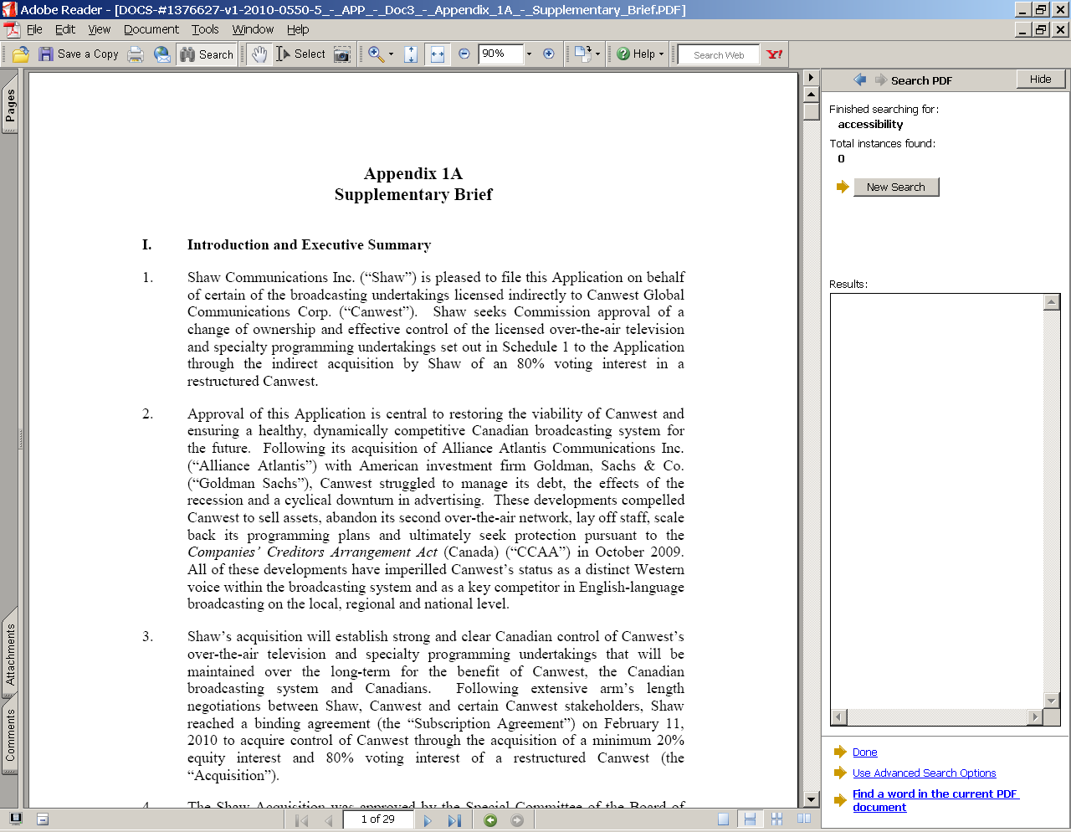

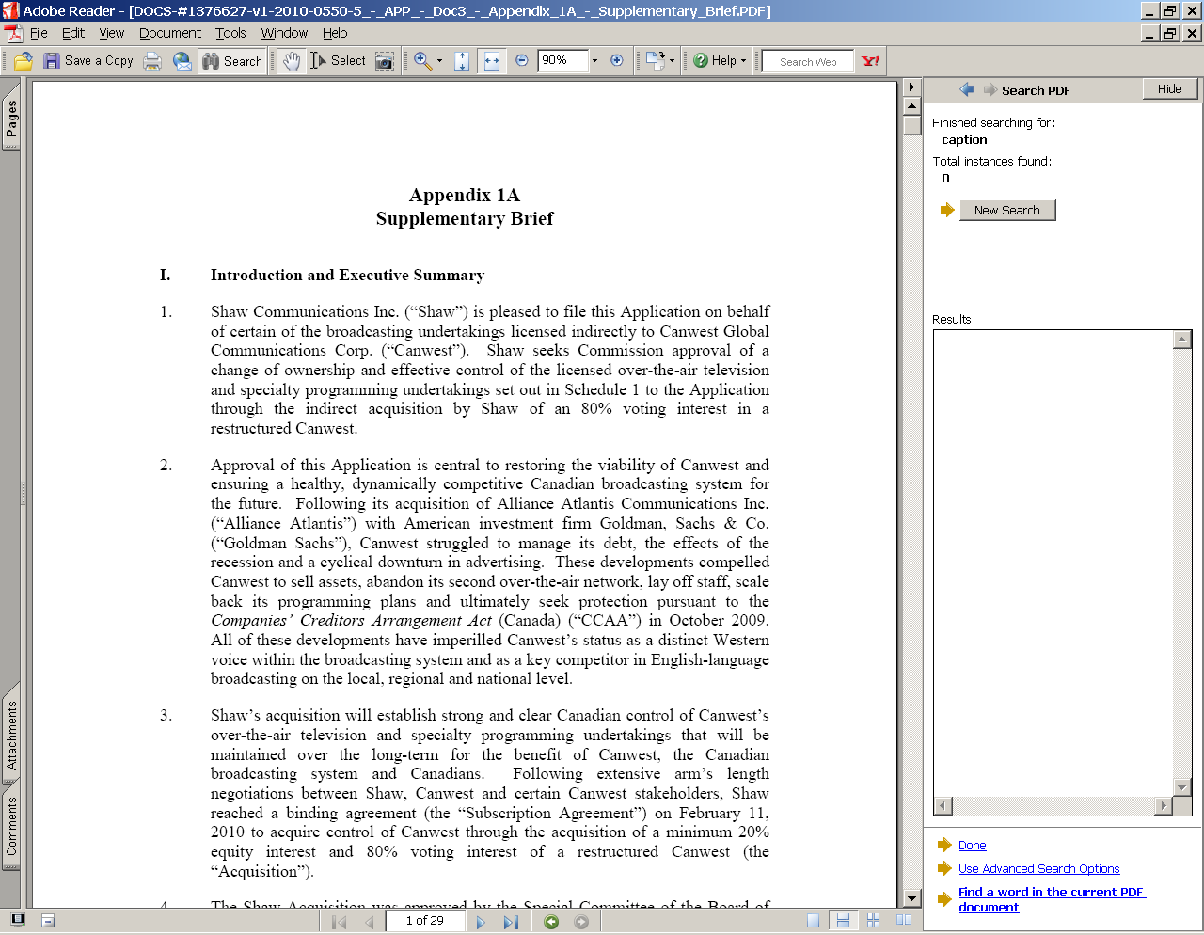

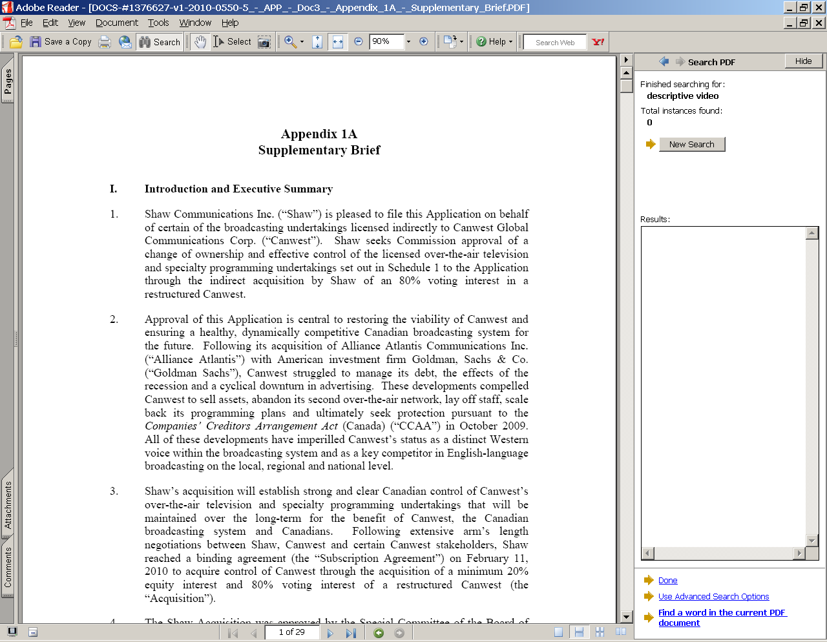
- Given Shaw’s clear commitment to accessibility, as demonstrated by its participation in the 2008/09 accessibility proceeding of the CRTC, it is both puzzling and disappointing that Shaw’s application ignores the needs and interests of hearing- and visually-impaired Canadians.
- We regret, therefore, that we cannot support Shaw’s application unless substantive changes are made to address the interests of Canadians who are visually- or hearing-impaired.

Media Access Canada’s Conclusion and Recommendations
- We are aware that Shaw, Canwest’s board of directors, an Ontario court and the Competition Bureau have each approved this transaction. Their authority and legal jurisdiction over broadcast licensing are limited, however.
- We are relying on the CRTC to protect the rights, needs and interests of the 14% of Canadians who are entitled to benefit from Canada’s broadcasting system, and this transaction, and who cannot rely on the competitive marketplace to serve their interests.
- We respectfully submit that the CRTC must address the absence of information about and commitments to accessibility in Shaw’s application.
- Given that the CRTC must ensure that all Canadians benefit from this transaction – including those with disabilities, the CRTC cannot approve Shaw’s application as it has been presented to Canadians because Shaw has provided no information about current levels of accessibility and has made no commitments about accessibility exhibition and expenditure even within its July 12, 2010 supplementary response to the CRTC in which it claims to have increased its ‘tangible benefits’ levels to $203 million.
- We respectfully submit that the status quo insofar as accessibility is concerned, is simply not an option. It is true that descriptive video hours have doubled from 2001 to 2008 (similar to the increase in closed captioning hours, that doubled between 1981 and 1987). But the simple fact is that as of the 2011 broadcast year, visually impaired Canadians will be receiving just two hours of original descriptive video content. If descriptive video requirements follow the pattern of closed captioning requirements (which took 26 years to achieve full captioning over the broadcast day), visually-impaired Canadians will not fully benefit from the broadcasting system until 2036. With respect, this is not acceptable – not only because this time frame would force Canadians with disabilities to wait an unreasonably long time for equitable access to their own broadcasting system, but also because the continued lack of accessible content in Canadian television programming services is likely to discourage affected Canadians from upgrading to digital programming services.
- What can be done to provide described video in a more reasonable time frame, and how much would that cost? Given the limited time available to consider Shaw’s application, we have devised limited projections about the costs involved to increase descriptive video content for Canadians. The chart below begins with the assumption that an hour of described video content now costs approximately $2,000. At this rate, we estimate that providing 2 hours/week of original described video content costs approximately $200 thousand, and yields 208 hours per year. (We invite the CRTC, however, to question Canwest and Shaw at the public hearing component of this proceeding, to elicit more accurate figures.)

Estimated costs per station of described video
Year | Original hours/ week | Cost/hour (5% annual reduction) | Total cost/ week | Total cost/ year | Repeat hours | Total hours per year | % of broadcast year  (52 broadcast weeks)
 |  |  |  |  |  |  | Full schedule | 60% of schedule
2010/11 | 2 | $ 2,000 | $ 4,000 | $ 208,000 | 2 | 208 | 3% | 5%
2011/12 | 4 | $ 1,900 | $ 7,600 | $ 395,200 | 4 | 416 | 6% | 11%
2012/13 | 6 | $ 1,805 | $ 10,830 | $ 563,160 | 6 | 624 | 10% | 16%
2013/14 | 8 | $ 1,715 | $ 13,718 | $ 713,336 | 8 | 832 | 13% | 21%
2014/15 | 10 | $ 1,629 | $ 16,290 | $ 847,087 | 10 | 1040 | 16% | 26%
2015/16 | 13 | $ 1,548 | $ 20,118 | $ 1,046,152 | 13 | 1352 | 21% | 34%
2016/17 | 17 | $ 1,470 | $ 24,993 | $ 1,299,642 | 17 | 1768 | 27% | 45%
2017/18 | 23 | $ 1,397 | $ 32,124 | $ 1,670,423 | 23 | 2392 | 37% | 61%
2018/19 | 29 | $ 1,327 | $ 38,478 | $ 2,000,876 | 29 | 3016 | 46% | 77%
2019/20 | 36 | $ 1,260 | $ 45,378 | $ 2,359,654 | 36 | 3744 | 57% | 95%
2020/21 | 44 | $ 1,197 | $ 52,689 | $ 2,739,820 | 44 | 4576 | 70% | 100%

- Based on the experience of the closed captioning industry, however, it is clear that hourly costs will fall. As noted earlier, closed captioning expenditures by private television stations have decreased over the past decade – by 43% between 2006 and 2009, for example. Part of this reduction in expenditures may be due to the fact that as ownership groups consolidate continues, they can more readily amortize programming and accessibility costs over larger numbers of stations (in that, for example, the same programming is carried by more stations).
- While we cannot make any precise claims about future costs, we show in the chart above the estimated costs if the hourly cost of described video declines 5% per year and described video hours double each year. In this scenario, the cost of described video would decrease to roughly half in ten years, by which time the Canadian broadcast schedule would be fully described. Note as well that the broadcasting industry would benefit through the creation of new employment.
- We believe a fully-described broadcast schedule is a true tangible benefit for Canada’s broadcasting system and Canadian audiences. If larger media ownership groups are able to draw benefits from consolidated ownership, so too should Canadians with disabilities.
- We respectfully submit that a company of Shaw’s stature, could and should take the lead – especially if it seeks to demonstrate its commitment to Canada’s broadcasting system and Parliament’s broadcasting policy.
- As for the timing of such commitments, we have noted the CRTC’s statement that it will consider the licence renewals of large groups such as Canwest next spring. We assume, therefore, that even if the CRTC grants Shaw’s application and amends the Canwest licences to reflect Shaw’s control, the CRTC will still consider longer-term renewals of the programming services in 2011. We therefore believe that would be the appropriate time to consider and impose specific levels of accessible content conditions of licence.
- Our ten recommendations are therefore largely focussed on how the CRTC’s determinations in this proceeding could strengthen the accessibility of Canada’s communications system for Canadians.

Recommendation 1: The CRTC should report on levels of original and repeat closed captioned and described video programming broadcast by Canwest stations by station and broadcast year since 2000

Recommendation 2: The CRTC should report on Canwest’s expenditures on closed captioning and descriptive video since 2000

Recommendation 3: The CRTC must set minimum levels of closed-captioned and descriptive video content by condition of licence, with the understanding that these levels will be reassessed in 2011

Recommendation 4: The CRTC must require that Shaw’s Canadian content complies with industry standards for accessible content

Recommendation 5: The CRTC must establish that minimum levels of accessible content in its programming content (whether over-the-air, by satellite or online) will increase over time, regardless of the financial circumstances of the licensee or its licensed undertakings

Recommendation 6: A portion of the benefits from this transaction should be invested in technology to reduce accessible content production costs, and to ensure the availability of after-market access devices

Recommendation 7: The CRTC should require that part of the benefits of this transaction establish an Education Envelope to expand markets for accessible content and ensure that people with disabilities are aware of the availability of accessible content

Recommendation 8: The CRTC should require Shaw to participate in the development of harmonized industry standards for accessible content that would consolidate closed captioning and descriptive video production and distribution, as well as multiple platform distribution, across Canada’s communications system (whether regulated, exempted or forborne)

Recommendation 9: The CRTC should require Shaw to contribute to the funding of an arms-length compliance measurement body that would take random samples of programming to report on the achievement of accessible content requirements across Canada’s communications system

Recommendation 10: The CRTC should require Shaw to contribute to the establishment of a central clearing house for archiving and distributing accessible content to the domestic and international communciations systems
- We thank the CRTC for the opportunity to participate in this process, and look forward to discussing our submission at the Calgary public hearing.

*** End of document ***

E-mails available to the CRTC upon request.
11 February 2010. Shaw Communications Inc., Application by Shaw Communications Inc. for approval of its acquisition of effective control of the licensed undertakings indirectly owned by a restructured Canwest Global Communications Corp., Appendix 1A: Supplementary Brief, (Ottawa, 30 March 2010) at ¶2 [Supplementary Brief].
Shaw, RE: Amendment to the Application by Shaw Communications Inc. for approval of a change of ownership and effective control of the licensed over-the-air and specialty programming undertakings indirectly owned by a restructured Canwest Global Communications Corp. (the “Application”) – Application No.: 2010-0550-5, Letter to the CRTC (4 May 2010) at 1, ¶¶2-3.
Shaw, Re: Application by Shaw Communications Inc. on behalf of Canwest Global Communications Corp. and all the licensees – Transfer of shares/Change of effective control – Application No. 2010-0550-5 (20 May 2010) Response to question 17 a) at 3.
Shaw, Supplementary Brief, at ¶ 21.
Ibid. at ¶ 22.
Ibid. at ¶ 21.
Ibid. at ¶ 29.
Shaw, Re: Application by Shaw Communications Inc. on behalf of Canwest Global Communications Corp. and all the licensees – Transfer of shares/Change of effective control – Application No. 2010-0550-5 (19 May 2010) response to question 3C, at 9.
Ibid., at Appendix 2.
In 669 BCE, for example, Assyria’s King established a library, but censored its contents (“Ashurbanipal, the First Librarian” <http://web.utk.edu/~jdavis41/ashurbanipal.html>). In 213 BCE, Emperor Shihuang of Chian ordered the destruction of all books in the country, as well as the execution of 500 scholars (The Media History Project, “The Centuries Before the Common Era”, <http://www.mediahistory.umn.edu/time/ bce.html>; <http://www.ma-radio.gold.ac.uk/HISTORYOFMEDIALAW/>). After the invention of the printing press in 1454, Pope Innocent VIII decreed in 1467 that all books related to Christian doctrine were to be submitted to local Church authorities for pre-publication approval and licensing (<http://www.lumenverum.com/apologetics/forbidden.htm>).
“Trying to shut out the light by banning books”, <http://www.freedomforum.org/templates/document.asp?documentID=3628> . His reason?: to limit debate about a threat to his legitimacy as monarch, namely the Catholic Church’s consideration of ex communication to sanction the King’s divorces and failure to abide by Church doctrine.
J. Hagan, Printers and Politics, (Australian National University Press: Canberra, 1966) at 93.
Johann Gensfleisch zum Gutenberg invented the printing press in Germany, in 1450; by 1486 the first secular censorship office was established in Mainz. “Chronology” online <http://apm.brookes.ac.uk/publishing/contexts/impact/chronol.htm >; “Trying to shut out the light by banning books”, online: <http://www.freedomforum.org/templates/document.asp?documentID=3628>.
John Milton, “Areopagitica” online: < http://www.bartleby.com/3/3/2.html > (The Harvard Classics).
R. v. Boucher, [1951] S.C.R. 265. Justice Rand expanded on these views in 1957 in Switzman v. Ebling, [1957] S.C.R. 285, in which Switzman contested the right of his landlady to evict him because he had used the leased premises for ‘propagating communism’ contrary to provincial legislation. Justice Rand linked freedom of expression to democratic government
Canadian Bill of Rights, ss.1(d) and 1(f), respectively.
Part I of the Constitution Act, 1982, being Schedule B to the Canadian Act 1982 (U.K.), 1982, c. 11 [Charter].
As a statute of Parliament rather than a constitutional document, the Bill of Rights applied only to matters within the federal government’s power, and like other legislation, could have been amended by Parliament alone. Its effect on and authority over other statutes was open to question. See P. Maclem et al, Canadian Constitutional Law, 2nd ed. (Toronto: Emond Montgomery Publications Limited, 1997) at 591.
RWDSU v. Dolphin Delivery Ltd., [1986] 2 S.C.R. 573 at 583 (per McIntyre J. for the majority).
Ford v. Quebec (Attorney General), [1988] 2 S.C.R. 712 at 767 [Ford]: “… as listeners and readers, members of the public have a right to information pertaining to public institutions and particularly the courts. Here the press plays a fundamentally important role.” Parliamentary government “… demands the condition of a virtually unobstructed access to and diffusion of ideas….” and “freedom of discussion in Canada …has a unity of interest and significance extending equally to every part of the Dominion. …”.
Edmonton Journal v. Alberta (Attorney General), [1989] 2 S.C.R. 1326 (per Cory J. for Dickson CJ and Lamer J.)
Ford, supra note 22.
Thomas L. McPhail & Brenda M. McPhail, Communication: The Canadian Experience, (Mississauga: Copp Clark Pitman Ltd., 1990) at 117-140.
The Asper family then controlled television, radio and specialty services, as well as newspapers across Canada: Interviewed in his Winnipeg office, David [Asper] was bubbling with enthusiasm in his role as content guru. … “We now have this whole content engine. As a means to understanding who the papers work, how its content is generated and in shaping a view or editorial direction, one of us needs to be accountable for these businesses. They’re important and they shape people’s attitudes and perceptions and that’s principally what I’m doing.” Gordon Pitts, Kings of Convergence: The fight for control of Canada’s media, (Canada: Doubleday Canada, 2002) at 266 [Kings of Convergence]..
In 1995 the CRTC noted that “[t]elevision has become an essential tool in the robust debate and free exchange of ideas that nourish a democratic society. Canadian communications media have accepted a role based on the marketplace of ideas.” CRTC, Introduction to Decisions Renewing the Licences of Privately-owned English-language television stations, Public Notice CRTC 1995-48 (24 March 1995) <http://www.crtc.gc.ca/archive/ENG/Notices/1995/PB95-48.HTM>.
Ibid., at ¶¶ 56-57 (references omitted).
[1997] 3 S.C.R. 624, at ¶20.
Ibid., at ¶42.
Ibid., at ¶22, citing Slaight Communications Inc. v. Davidson, 1989 CanLII 92 (S.C.C.), [1989] 1 S.C.R. 1038.
Ibid., at ¶20.
We last checked the CRTC’s proceedings webpage for new materials regarding the application at 8 am Saturday, August 21, 2010.
Supplementary Brief, at ¶41.
The distinction is set out by Ruth Sullivan, Sullivan and Driedger on the Construction of Statutes (4th ed.) (Butterworths: 2002) at 65: … In ordinary usage, “should” indicates a preferred course of action but it does not make that preference binding.
CRTC questions to parties, noted in Shaw Telecom Inc.(CRTC)10June08-100.
A new policy with respect to closed captioning, Broadcasting Public Notice CRTC 2007-54 (Ottawa, 17 May 2007): … the on-screen textual representation of the audio component of a program. It is presented as a banner, usually at the bottom of the screen, and provides a text rendition of all significant audio content, including on-screen dialog, sound effects and non-speech information such as the identity of speakers and their manner of speaking. It is generally made available in a closed format via line 21 of the vertical blanking interval.
VoicePrint (licensed to NBRS) is a national broadcast reading service that the CRTC has designed as a mandatory service necessary to achieve the objectives of the Act.
While this is an important service, we note that one described programming service is not a substitute for the many other television programming services the majority of whose programming is not described.
In Renewal of the Canadian Broadcasting Corporation’s television and radio network licences, Decision CRTC 79-320 (Ottawa, 30 April 1979) at 40.
Services using the Vertical Blanking Interval (Television) or Subsidiary Communications Multiplex Operation (FM) Introduction, Public Notice CRTC 1984-117 (Ottawa, 17 May 1984).
Introduction To Decisions Renewing the Licences of Privately-Owned English-Language Television Stations, Public Notice CRTC 1995-48 (Ottawa, 24 March 1995).
A new policy with respect to closed captioning, Broadcasting Public Notice CRTC 2007-54 (Ottawa, 17 May 2007).
Licence renewals for the television stations controlled by Global, Decision CRTC 2001-458 (Ottawa, 2 August 2001) at ¶73.
A group-based approach to the licensing of private television services, Broadcasting Regulatory Policy CRTC 2010-167 (Ottawa, 22 March 2010): 105. In the case of changes in control of a service, including acquisitions and sales of assets, both parties will be required to demonstrate that each service has met its obligations, including its CPE conditions of licence, as may be affected by the flexibility afforded in the group-based approach.
Broadcasting and Telecom Regulatory Policy CRTC 2009-430 (Ottawa, 21 July 2009).
Ibid., at ¶8.
Canwest Media Inc., Re: Broadcasting Notice of Public Hearing (BPNH) CRTC 2008-8: Unresolved issues related to the accessibility of telecommunications and broadcasting services to persons with disabilities, (6 October 2008), at ¶11.
Ibid., at ¶75, 98.
Ibid., at ¶122.
CRTC, “CRTC takes steps to improve access to communications services for Canadians”, News release (Ottawa, 21 July 2009) <http://www.crtc.gc.ca/eng/com100/2009/r090721.htm>.
CRTC, “Current described video requirements for TV services”, online: CRTC.gc.ca < http://www.crtc.gc.ca/eng/info_sht/b323.htm>.
That is, there is neither a fact sheet to show results from licensees’ logs, nor consistent reporting within the CRTC’s licensing and licence renewal decisions to show accessibility requirements by calendar year (rather than the confusing, year 1 – year 2 – year 3 system now used).
And as ownership has consolidated, allowing programming to be re-used across more platforms.
Canadian Broadcasting Corporation/Société Radio-Canada Applications for the Renewal of the English and French Television Network Licences, Decision CRTC 87-149 (Ottawa, 23 February 1987): Beginning with a commitment to present five hours per week of closed captioning in each language, the Corporation has increased its output over the current licence term to an average of ten hours per week. At the recent hearing, the Corporation stated that it would distribute an average of fifteen hours per week of closed captioned programming during the 1986/87 fall/winter season. This would be accomplished by reducing the amount of closed captioned programming made available during the summer months: the annual average, however, would remain at about ten hours per week. Nevertheless, including repeats, the Corporation expects to exceed 1,000 hours of closed captioned programming this year. At the hearing, the CBC stated that the annual amount allocated for closed captioning has remained at $1.7 million for the last two years and that it will probably remain at this level for the next three to five years. Nevertheless, the Corporation was optimistic that improvements in productivity will mean that more hours of captioned programs can be produced for the same amount.
Shaw, RE: Amendment to the Application by Shaw Communications Inc. for approval of a change of ownership and effective control of the licensed over-the-air and specialty programming undertakings indirectly owned by a restructured Canwest Global Communications Corp. (the “Application”) – Application No.: 2010-0550-5, Letter to the CRTC (4 May 2010) at 1, ¶¶2-3.
Shaw, Re: Application by Shaw Communications Inc. on behalf of Canwest Global Communications Corp. and all the licensees – Transfer of shares/Change of effective control – Application No. 2010-0550-5 (20 May 2010) Response to question 17 a) at 3.
Shaw, Re: Application by Shaw Communications Inc. on behalf of Canwest Global Communications Corp. and all the licensees – Transfer of shares/Change of effective control – Application No. 2010-0550-5 (19 May 2010) response to question 3C, at 9.
Ibid. at Appendix 2.
Unreasonable, because if the CRTC were to simply accept shell corporations as the ‘true’ licensee, every broadcaster would create penniless legal shells to be licensee companies, and thereby game the system by artificially limiting benefits for the broadcasting system and Canadians.
Shaw Communications Inc., 2009 Annual Report, at 61.
Ibid. at 6.
Ibid. at 90.
Ibid. at 35.
Shaw, “Shaw and Corus Launch a 3-D Revolution” Press Release (Calgary and Toronto, 6 May 2009) <http://www.shaw.ca/NR/rdonlyres/AA62E715-F58F-45FF-B389-38B60B577C8B/0/ShawCorus3DMay6.pdf>.
Shaw Communications Inc., 2009 Annual Report, at 51.
Ibid. at 35.
Supplementary Brief: 51.The Acquisition brings together a well-financed group of investors, including Shaw as the key strategic investor, willing to dedicate the necessary financial resources and expertise to restoring the strength of Canwest. Shaw has a strong track-record of successful acquisitions (including CUC Communications, Star Choice, Cancom, Moffat Communications Limited, cable systems in Vancouver and surrounding areas pursuant to an asset swap with Roger Cable and, most recently, Mountain Cable) and in establishing successful and strong businesses (including internet and digital telephony).
Supplementary Brief, at 56.
Shaw, Re: Unresolved issues related to the accessibility of telecommunications and broadcasting services for persons with disabilities, Broadcasting Notice of Public Hearing CRTC 2008-8 and Telecom Public Notice CRTC 2008-8 – Final Reply Comments, Letter to CRTC (Ottawa, 12 January 2008) at 1
Shaw Telecom Inc.(CRTC)10June08-100 (b).
Shaw Telecom Inc.(CRTC)10June08-100 (c).
Shaw Telecom/Broadcasting proceeding, Shaw Telecom Inc.(CRTC)10June08-100.
Shaw, Re: Unresolved issues related to the accessibility of telecommunications and broadcasting services for persons with disabilities, Broadcasting Notice of Public Hearing CRTC 2008-8 and Telecom Public Notice CRTC 2008-8 – Final Reply Comments, Letter to CRTC (Ottawa, 12 January 2008) at ¶3.
Broadcasting and Telecom Regulatory Policy CRTC 2009-430 (Ottawa, 21 July 2009) at ¶¶126-127.
Broadcasting Regulatory Policy CRTC 2010-167 (Group Licensing Policy), at ¶103: 103. With respect to the Commission's various social policies – those governing accessibility, cultural diversity, and adherence to programming standards via regulations, industry codes and membership in the Canadian Broadcast Standards Council –, the Commission reiterates that the obligations related to these policies will continue under the group-based approach.
Licence renewals for the television stations controlled by Global, Decision CRTC 2001-458 (Ottawa, 2 August 2001) at ¶¶69 and 73.
Ibid.
Ibid., at ¶70.
Ibid., at ¶71.
Ibid., at ¶73.
Ibid., at ¶72.
Transfer of effective control of CHUM Limited to CTVglobemedia Inc., Broadcasting Decision CRTC 2007-165 (Ottawa, 8 June 2007) at ¶ 36.
Building on Success – a policy framework for Canadian television, Public Notice CRTC 1999-97 (Ottawa, 11 June 1999).
Transfer of effective control of CHUM Limited to CTVglobemedia Inc., Broadcasting Decision CRTC 2007-165 (Ottawa, 8 June 2007) at ¶ 36.
Ibid.
Ibid.: 37. CTVgm's purchase price for the shares amounts to $1,365 million. CTVgm determined this value to be the value of the transaction on which they proposed a tangible benefits package of $103.5 million. 38. In most of the previous transactions, the value of the transaction was equivalent to the purchase price for the shares plus the value of assumed debt. In assessing the value of the transaction, CTVgm excluded CHUM's long-term debt of $270 million and operating leases and other commitments of $65.5 million. The latter, as financing alternatives, are considered as debt. The Commission has therefore determined that the value of the transaction should take into account these assumed liabilities and concludes that the revised value of the transaction amounts to $1,700.5 million.
National Broadcast Reading Service, Re: Application No. 2007-0700-5, Intervention in support of Canwest’s purchase of Alliance Atlantis (Toronto, 30 July 2007) at ¶9.
Toronto International Deaf Film and Arts Festival, Intervention in support of Canwest’s purchase of Alliance Atlantis, (10 August 2007) at 1.
Media Access Canada received the grant to make this project possible.
Shaw’s Supplementary Brief, at 21 ¶94 (italics in original).
Shaw, Supplementary Brief, para. 68.
Shaw, Supplementary Brief, para. 8.
Shaw, Supplementary Brief, para. 48.
Shaw, Supplementary Brief, para. 11.
Shaw, Supplementary Brief, para. 19.
Shaw, Supplementary Brief, para. 51.
Shaw, Supplementary Brief, para. 10.
Shaw, Application by Shaw Communications Inc. on behalf of Canwest Global Communications Corp. and all the licensees – Transfer of shares/Change of effective control – Application No. 2010-0550-5, Letter (12 July 2010), at 2.
Shaw’s 12 July 2010 response to CRTC’s 26 May 2010 questions, at 2-3.
Ibid., at Appendix 1.
Ibid., at 4.
In constant 2002 dollars from $65.2 thousand per station in 2006, to $35.2 thousand per station in 2009.
Assumed to comprise 60% of the broadcast day.
And the Canadian economy.
Given the lack of resources available to the CBC.

