Monitor 2
Phase 1 of 2

A Report on the Quantity of Accessible Content in
Canadian Broadcasting in 2010

Prepared for:



April 2011

Prepared by:



Monitor 2: Phase 1 Report on the Quantity of Accessible Content in Canadian Broadcasting at 2010

Copyright@ 2011 by Media Access Canada

All rights reserved. No part of this publication may be reproduced or transmitted in any form or any means, or stored in a data base or retrieval system, without the prior written permission of Media Access Canada

Published by
Media Access Canada
110 Pricefield Road
Toronto, Ontario
M4W 1Z9
Editor
Beverley Milligan
Researchers
Stoney Baker
Sarah Eagen
Eben Holmes
Heather Largy
Haylea Ostafichuk
Ashley Rensler
Sarah Neale
Engineering
John Stubbs
Software design
Xavier Snellgrove
Accessibility
Andrew Morris

Table of Contents

Acknowledgements ……………………………………………………… 4

Executive Summary ……………………………….………………...….. 5

Introduction ……………………………...……………………………….. 6

Background: Monitor 1 ………………………………………………..... 9

Project Description: Monitor 2 ……………………………………...….. 10
i) Project Scope
ii) Literature Review

Methodology ……………………………………………………………… 12
i) Overview
ii) Key Questions
iii) Equipment
iv) Accessibility Lens
v) Coding Overview
vi) Coding for Closed Captioning
vii) Captioning Errors
viii) Coding for Video Description
ix) Description Errors

Quantitative Results ……………………………………………………. 20

Conclusion ………………………………………………………………. 36

Next Steps ………………………………………………………………. 38

Appendix ………………………………………………………………… 40

1. Canadian Media Fund Accessibility Policy
2. Captioning Lag
3. Glossary of terms used

Acknowledgements

The publisher, editor and staff, along with disability and stakeholder organizations would like to thank the following organizations and individuals for providing their support, which has made this project possible:

CTV:
Without the core funding provided by CTV to Beverley Milligan, this project would not have been possible. The first Monitor Project was conducted over 19 years ago and there has been no further research in the area of accessibility in Canadian broadcasting since that time. Funding research is always difficult, particularly in areas of accessibility. It takes a visionary leader and good corporate citizen to commit to funding the development of innovative research tools and best practices and the acquisition of statistical data, which will impact the quantity and quality of accessible content going forward.

Ryerson University:
The management, faculty and students of Ryerson have supported this research from the outset. They ensured high academic standards by the provision of qualified part time and summer students to assist in the monitoring and analysis of data. Engaging students to participate in cutting-edge research, such as the Monitor 2 project, has also stimulated interest in curriculum development and academic publishing in the field of accessibility. Such an increase in expertise is vital to support further developments in the field of accessibility.

Industry Canada:
As a leader in accessible technology standards and accessible industry development, Industry Canada has always distinguished itself as a governmental body committed to accessibility issues. Through its underwriting of research, to archiving policy development in and around captioning and description, Industry Canada has been an invaluable contributor to the ongoing development of environmental analysis.

ARC:
In 2009, Beverley Milligan on behalf of her company, Analysis and Research in Communications, (ARC) received a grant from the CTV Chum Tangible Benefits Fund, to conduct research into the state of accessible content in Canadian broadcasting. Upon incorporating the not-for-profit organization, Media Access Canada (MAC) in April 2010, ARC agreed to allow MAC to publish, at no cost, key results from this study to ensure full access by all industry stakeholders and to in inform the development of standards and best practices within the context of the Accessible Content Best Practices Guide for Digital Environments, and in cooperation with CRTC objectives.

MAC would like to thank ARC, for providing on-going expertise to support MAC in achieving its objectives.

Individual Contributors:
We would like to thank all of those individuals who have contributed their time to ensuring the quality of this report meets with academic and empirical standards. To name a few: Monica Auer, Mary Frances Laughton, Deb Finn, Chuck Letourneau, Ann Dugan, Yves Seguin, Deb Fels, J.P. Udo, Lisa Copeland, Maria Reis and many others who have volunteered their time to this project.

Executive Summary

This report is Phase one of the Monitor 2 Report on Accessible Content in Canadian Broadcasting. The final report is to be published in June 2012. Its contents will incorporate the quantitative report provided here, along with a qualitative and environmental analysis that will inform standards and best practices for accessible content in Canadian broadcasting.

Monitor 2 is based on the analysis of over 1,800 hours of Canadian broadcasting, examining both qualitative and quantitative measures of closed captioning and descriptive video. Monitor 2 evaluates the quality and quantity of accessible content in Canadian Broadcasting as of 2010. It examines developments in the industry since the Monitor 1 study published in 1993 and discusses the impact of policy, funding and other factors. Finally, the report makes recommendations for the future.
The key findings of the report show that Canadian broadcasters have made dramatic improvements in the provision of closed captioning (CC) with most Canadian broadcasters in compliance with the CRTC guidelines though some fall far short. On the other hand, provision of descriptive video (DV) has not kept pace and there are enormous discrepancies between broadcasters. No important variation was found between prime time and non-prime time broadcasts nor were significant differences found between the regulated and unregulated portion of the broadcast day.

While the qualitative phase will generate more issues around user quality preferences, the quantity of errors and error types were counted. Large variations were found in quality of closed captioning, with some broadcasters demonstrating significantly higher rates of error. Descriptive video, while lagging in terms of quantity, was found to be of generally high quality with few errors.

Introduction

Monitor 2 is a report on the current state of accessible content in the Canadian broadcast industry with an objective to inform and support the development of policy, standards and best practices for Canadian broadcasting; to examine the impact of accessibility policies on Canadian broadcasting since the first Monitor Project; and, to begin an examination of Descriptive Video (DV), within those contexts.

This Phase1 report will document the findings of the monitoring study, which measured, examined and analyzed closed captioning (CC) and Descriptive Video (DV) in over 1,800 hours of Canadian broadcasting content.

The design, analysis and drafting of the first Monitor Project occurred over 19 years ago, with publication in 1993. The first challenge in designing the Monitor 2 project was to adapt to the enormous changes in the broadcast industry over the intervening decades. While maintaining the basic design of Monitor 1, the second study went on to map changes in three key areas: quantity, quality and most importantly, environment. Environment should be understood to mean the developments in the broadcast environment and the causes of those developments.

At the time of Monitor 1 there were three distinct production methodologies for captioning: off-line, real-time and live-display. Off-line captions are added to pre-recorded video content. Captioners listen to the video and transcribe the dialogue. The captions are then timecoded to sync with the audio and encoded into the video signal. User of off-line captioning will see pop-on captions.
With real-time captioning captions are prepared and transmitted at the time of origination by specially trained real-time captioners using a stenotype machine. Live sporting events and news programs rely heavily on real-time captioning for obvious reasons. Real-time captions will generally scroll at the bottom of a television screen, although the real-time captioner may move the 3-4 line scroll to the top of the television screen in order to avoid blocking critical information.
Live-display captioning is used when an accurate script or videotape is available prior to the program telecast. Captions are prepared in advance and stored on a computer disk. As the program is telecast a captioner pushes a button on the captioning system to display each caption. The roll-up captions appear line-by-line and are synchronized as closely as possible with the program audio. A real-time captioner may use live-display for scripted portions of a live program. We also see live display used in postproduction live looking programs like documentaries.
The first Monitor Project found the production technique of live-display to be the single largest quality issue in Canadian broadcasting, due to its reliance on a script. At the time, only the scripted portions of a news program were captioned, leaving the remainder of the program not captioned. In the years since the Monitor 1 study live-display is no longer used as a stand-alone method for real-time captioning but remains key within certain CRTC program categories such as documentaries. Live-display now reduces cost and generates the fewest errors of all production styles. It is a technique of tremendous value in both live and post-production environments.

As of 2010, real-time captioning; stenographer-based real-time transcription, generates the poorest quality of captioning, exceeding both off-line and live-display in error rates. Real-time captioning is by far the single source of captioning subcontracted by Canadian broadcasters. It is notable that the error rate in Monitor 1 and in this interim report is highest for live programming regardless of production methodology. The challenge therefore is to improve live captioning techniques and develop quality standards that address the fact that real-time captioning is not done in-house by the broadcaster, but subcontracted to a real-time captioning production facility.

Real-time captions roll-up the television screen. Post-production captions either pop-on or roll-up. Pop-on captions are produced using off-line or post-production software and a real-time captioner will use a combination of stenography and live display to produce roll-up. The real-time captioner can move the captions up and down the screen to ensure critical video information is not covered by the captioning.
In the past emphasis on standards focused on the elimination of live display because of high rates of error. Our findings, however, indicate that live display does have a place both in live and post-production programming environments and the more important issue is what the viewer sees. Technical innovation will inevitably cause changes in production methods. Standards should focus instead on presentation: for example requiring roll-up captions for live and live looking programming and pop-on for all other programming.

This document will focus heavily on CC rather than DV for two reasons: first, because Monitor 1 did not include DV as it did not exist in broadcasting in 1993 and therefore no comparison could be drawn. The second, and a key point in this report is that the samples recoded for monitoring DV resulted in a maximum of 27.8% of described programming. This translates to only 3 of the 10 broadcasters sample having any descriptions.

Over the last 19 years, other key changes have occurred for methodologies, for example printed program guides no longer appear in Saturday newspapers. For Canadians with disabilities this creates a problem: where to acquire information regarding captioned or described programming. An announcement at the beginning of a program is not sufficient as it makes planning impossible.
Accessibility information could be available elsewhere, such as the individual broadcasters’ web sites or electronic listings of the Broadcast Distribution Undertaking (BDU). At the moment neither contains any indication of accessibility for any content. In the case of Bell ExpressVu, due to the technical challenges associated with passing through the Second Audio Channel, (SAP), they have assigned dedicated channels for open description and DV listings.

The CRTC is moving to a requirement of 100% captioning of all broadcasting in a 24 hour period, which would make identifying a program as captioned redundant, however, in the case of DV, where less than a third of the broadcast week is accessible, identifying when and where a described program can be found is more critical. While this study only examined the BDUs in respect of lag measurement and accessible content marketing, it is noteworthy that Bell ExpressVu provides the best access to described programs among all the BDUs, ironically enough, due to its inability to provide SAP.

Therefore, there is a strong indication that while standards are being developed for broadcasting, the listing of available DV programs may require a standard for BDU’s as well. Further, given broadcasters are mostly complying with 100% captioned broadcast day and moving to 100% of the entire 24 hour period, a program is assumed captioned bringing into question if there is still an need to identify a program as captioned.

The challenge to this easing of captioning identification requirements are those broadcasters not in compliance of 100% captioned broadcast day. By a few not complying, it creates work for all broadcasters through the redundant insertion of a identification, when it is assumed.

Although the scope of the study’s monitoring was targeted specifically to the regulated broadcast industry, as its purpose was to generate a report card on accessible content in Canadian broadcasting, the Web could not be ignored. For this reason, we conducted preliminary measurements of accessible content on the unregulated web sites of broadcast undertakings in order to assess the need for regulation. The findings were troubling. Programming that was provided captioned or described on the regulated distribution environments was never available on the broadcasters own websites. In addition, captions were generally stripped out when offered, “on-demand” from BDUs.

Standards and best practices must therefore address both procurement and distribution as key areas for new policy in a rapidly evolving environment where de-regulated distribution platforms are playing an ever-growing role.

Accessible content in Canadian broadcasting is either foreign acquired, broadcaster produced or acquired or funded by the Canadian Media Fund (CMF). From a television broadcast perspective, ensuring that a program is CC or DV is more often than not, an act of locating existing captions or descriptions, or ensuring that content deliverables arrive with CC or DV; rather than actually commissioning the work. The study data will show that most broadcaster-commissioned accessible content is found in live programming such as news and sporting events. Post-production CC or DV, as presented in both roll-up and pop-on, are most often foreign acquired, or CMF funded.

Other than captioning lag being an error as it caused dropped captions, it was not originally considered in this study. However, over the months that samples were monitored, it became a CRTC and industry priority to figure out lag, how often it occurred and its cause. Given the flexibility designed into the Accessibility Lens coding software and the ever-increasing need for additional data on lag, it was introduced into the study, not as part of the methodology used for the overall project, but treated independently to answer three questions:
1) Was there lag?
2) If so, how often and for how long?
3) What caused the lag?

Captioning lag, therefore, was a study within the study and was isolated to real-time captioned programming sampled from each of the ten broadcasters. Measuring caption lag time required the development of a different methodology and software algorithm. Therefore, captioning lag is dealt with in an appendix 2.

Monitor 2: a Report on Accessible Content in Canadian Broadcasting will be published no later than June 2012. Its contents will incorporate the quantitative report provided here, along with a qualitative and environmental report that will inform standards and best practices for accessible content in Canadian broadcasting. It will also provide the latest version of the Accessible Content Best Practices Guide for Digital Environments.

Background: Monitor 1 (conducted in 1992, published in 1993)

Between February and October 1992, LOBCO Inc. measured the quantity and quality of captioning from eight over-the-air English-language television broadcasters in southern Ontario. Each was recorded for twenty-four hours daily for one week, twice a month, in two separate months – yielding four weeks of programming content from each broadcaster. The recordings were analyzed to measure the quantity, method/style, linguistics, placement and timing of captioning. The content analysis results were then presented to seven focus groups, including members of the deaf and hard-of-hearing community, broadcasters and captioning producers.

In 1992 the CRTC did not mandate specific levels of captioning and Phase 1 of the study found that 32% and 31% of programming hours and programs, respectively, were captioned. Up to 20% of the dialogue in live-captioned programs was inaccessible to deaf, deafened and hard of hearing people because the captions were missing, not synchronized with dialogue, or unreadable due to excessive speed. Phase 2 of the study used focus groups to assess the reactions of broadcasters, consumer/user groups and accessibility producers to the Phase 1 results.

Following the publication of the Monitor report, the CRTC, in 1995, required over-the-air TV stations to ensure that 90% of their programs were captioned by 2002. It introduced requirements for described video in 2000 for each major broadcaster (CRTC, 2001).

In CRTC 2009-430, the Commission introduced a comprehensive disability policy in both broadcasting and telecommunications. Reference to website compliance was limited to customer service issues and did not consider accessible content.

Project Description: Monitor 2

Monitor 2 is a three-year research project to examine the quantity and quality of accessible content in Canadian broadcasting. The project involves the observation and analysis of over 1,800 hours of content, distributed across 10 broadcast license undertakings. This preliminary report is largely quantitative, as it examines the basic values of accessible content. These values include how much CC or DV is available, where did these originate, how many errors were introduced and where did these errors originate.

There are two phases in the Monitor 2 project represented by two reports – an interim and final report. The interim report discusses the quantitative results from the study. The final report will include further quantitative analysis, research from stakeholders, an environmental scan and analysis and recommendations.

This is the interim report of the Monitor 2 Project. The final report will be published in September 2012.

i) Project Scope

The aim of the Monitor 2 study is as follows:

- Evaluate the quantity and quality of accessible content in Canadian broadcasting as of 2010.
- Identify and compare differences from the Monitor 1 study.
- Analyze the environmental impact of policy, funding and other factors.
- Make recommendations for future advancement.

While technology and policy have evolved significantly, the methodology used, wherever possible, has remained true to that of the original Monitor Project. Monitor 2, like Monitor 1, looked at English-language Canadian broadcasters. Individual broadcasters were not identified and content sample was scheduled to be representative of the entire spectrum of broadcast content throughout the broadcast day. The Monitor 2 study expanded the sample-size of broadcasters from 8 to 10 in order to reflect an increase in channels and choice of broadcasters over the last 19 years. While Monitor 1 sampled only over-the-air (OTA) broadcasters in Ontario, the Monitor 2 study sampled not only OTA but also broadcasting provided through digital-cable services. Consideration was given to represent, within the selected samples, a diversity of ownership. (see Methodology, section iii.).

Over the past 19 years, changes to accessibility standards and regulation, as well as advances in accessibility technology, have raised the requirements for the provision of closed captioning to 100% of the broadcast day. The provision of DV content is currently at a level comparable to that of CC 19 years ago at the time of the Monitor 1 study. Phase 1 of the Monitor 2 research expanded the scope of the Monitor 1 project by looking into the provision of DV in addition to CC.

Like CC in 1992, DV services and practices are still in an early stage of development and implementation. While there are similarities between the evolution of CC and DV the conditions of licence are different. For example the requirement for CC is 100% of a broadcast day. The DV requirement is just 3% of a broadcast week therefore the sample size for CC was a 24 hour period while the sample size for DV was one week.

ii) Literature Review

A literature review to examine international and inter-jurisdictional documentation was conducted over four months in the summer of 2009 before finalizing the study design. Searches were done for CC standards, DV standards, research in CC and DV, as well as policy, precedent and law. Additionally, we sourced the JTC1 SWG – A Technology Reports, which lists any and all standards known to the International Standards Organization, ISO. In January 2011, we conducted another literature review to capture any additional information that has become available since the initial review in 2009.

These reviews form part of the background of the Monitor 2 study and will be reported in full in the final report in 2012.

Methodology

i.) Overview

In order to arrive at a representative picture of accessible content provision in Canada, the Monitor 2 study required samples representative of the regulatory requirements for each type of accessible content. Given the CRTC's requirement for a 100% closed-captioned broadcast day, the sample-size for CC was fixed at 24 hours per broadcaster and sampled at random. Initially, two (2) broadcasters were sampled simultaneously, with an approximate 10 second interruption at the 12 hour mark. After reconfiguring the equipment used for scheduling and recording the samples, we were able to sample an uninterrupted 24 hour period from each broadcaster.

The CRTC's requirements for DV correspond to a broadcast week, thus the DV sample was set to 7 consecutive days per broadcaster, in fourteen (14) 12-hour samples.

State-of-the-art digital video recorder (DVR) equipment was obtained for the express purpose of the pull-down. Digital-box DVRs connected to a laptop installed with TV tuner software allowed for direct recording of program content from the selected BDU to a digital hard drive where programming could be stored and accessible for monitoring at a later time. Pull-downs were scheduled ahead of time and checked regularly while recording in order to catch any possible problems or complications.

Ten broadcasters were sampled for both CC and DV, resulting in ten days—240 hours—of content to be monitored for CC and ten weeks—1680 hours—of content to be monitored for DV. The content sampling began in May 2010 and was completed in January 2011. The times of the sampling for each broadcaster were selected randomly, with care taken to avoid special events programming such as the 2010 Winter Olympic Games. On the rare occasion that a scheduled sample did not fully complete, i.e. if several minutes, or an hour of programming were missed due to a transmission failure, or an unforeseen glitch, then another complete sample was scheduled to replace it.

Throughout the preliminary analysis period the ratio of hours of monitoring/coding (data entry) per hour of broadcast content was carefully measured to gauge any increases in efficiency, as well as to anticipate the amount of work involved in monitoring and coding. This was done to determine whether the research and time-line objectives needed to be re-evaluated. It also provided an estimate of the hours and related costs, which could then be used in the creation of an operating budget and the development of a business plan for the customized monitoring of content for the rest of the project.

ii.) Key Questions

A series of questions was developed to create a coding procedure. This provided a framework for statistical reports to be generated by the Accessibility Lens software.

- What percentage of programs was closed captioned?
- What percentage of commercials/Public Service Announcements, PSA was closed captioned?
- What percentage of total content was closed captioned?
- What percentage of programs was described?
- What percentage of commercials was described?
- What percentage of total content was described?

- What technique was used to caption a given program?
(Roll-up or pop-on)
- What production technique was used to describe a given program? (Live or post-production)
- What is the origin of a given program? What is the origin of the CC or DV? (Canadian, American, other)
- What percentage of accessible programming content (CC and DV) was advertised?

In addition to the above questions related to the quantity of accessible content, questions concerning the quality were posed in order to track variations in the frequency of different kinds of errors:

- How many captioning spelling errors occurred during a given program? How many total spelling errors for all captioned programming?
- How many non-spelling caption errors occurred? (non-captioned segments, hidden information, synchronization errors) What was the average duration of an error?
- How many description-related errors were monitored? (non-described segments, low volume)

Taking into consideration relevant information related to programming available openly or free through the CRTC, ie broadcast logs, further questions were posed focusing on specific programming variables:

- What was the percentage of captioned content by program category?
- What was the percentage of described content by program category?
- What percentage of programming was closed-captioned by time of day? (prime-time vs. non)
- What percentage of programming was described by time of day? (prime-time vs. non)
- What percentage of accessible programming occurred on a volunteer basis, i.e. was non-broadcast day? (12am-6am)
- What was the percentage of caption errors by captioning technique?
- What accessible content distributed over the regulated infrastructure, to the home, was then streamed to a broadcasters web site and available captioned or described?
- Was a program identified as captioned or described at the beginning?
- Was a program reported as captioned or described on broadcaster logs actually captioned?
- Was the program advertised as CC or DV on-line or in paper listings guides?

iii). Equipment

To sample the programming from each of the selected broadcasters, digital video recording (DVR) apparatuses were tuned into a digital cable service and satellite feed via a laptop to a main hard drive capable of holding all of the data. The DVR software enabled the scheduling of all of the samples so that recording could take place in the absence of the researchers. When data had finished recording, another hard drive was used to copy data from the main hard drive to the other, temporary hard drive for monitoring. All data was backed up to ensure against data corruption or loss.

Coders used laptops installed with the proprietary DVR software in order to view the program content and headphones to ensure high fidelity audio during monitoring.

iv). Accessibility Lens

The Accessibility Lens is a computer program developed as a research tool and as an instrument of monitoring and evaluation for operational purposes. The Accessibility Lens was created first and foremost for the quantitative phase of the Monitor 2 study to produce reports in real-time. It is a software program that provides a fail-safe interface for the real-time coding of monitored broadcast content in which all necessary categories and relevant information appear as required input fields or as preset options from a drop-down menu.

The following are sample coding and reporting menus in the Accessibility Lens:

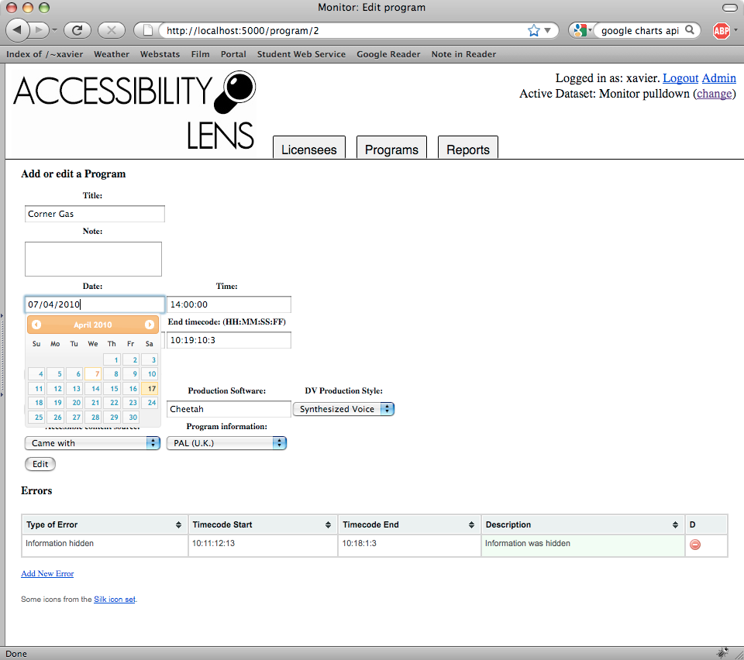

Description of screenshot (1 of 3): This is the program data entry page. Below the navigation tabs, there are two main sections: a user input section where the user can enter specific program data into the database, and an error reporting section where the user can log program errors into the database.

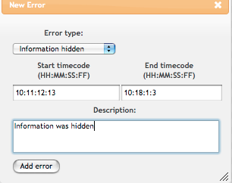

Description of screenshot (2 of 3): This is the error entry page, where the user can enter the program start and end time as well as a description of the error.

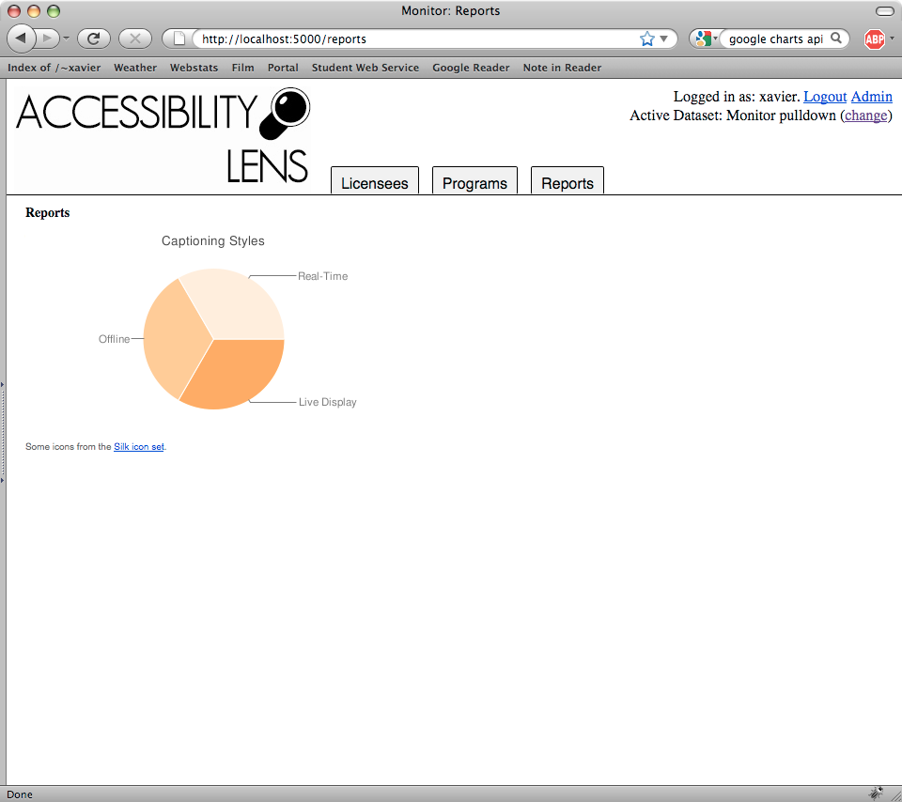

Description of screenshot (3 of 3): This is a sample report page. A pie chart titled Captioning Styles is displayed.

As a result of built-in analysis, coders required only limited training and data entry errors were minimized. Errors in timecoding were immediately apparent either through the visual timeline provided by the program entry interface or in the statistical values generated in the program list. By organizing the list by ascending/descending values, gross aberrations in program timecodes were immediately visible. Once coding was adjusted for these errors, the reports/graphs were recalculated with the corrected values in real-time. The Accessibility Lens automatically sorted and correlated the data, generating statistical reports based on the leading questions listed above. These reports present findings on the data collected by the Monitor 2 study in a series of visualizations and graphs.

The Accessibility Lens, in addition to providing an interface for efficient and secure coding of sample materials, functions as a customizable statistical
analysis engine. For this reason, there is a vast amount of data in the Lens, which will not be used in this report, but is available for future analysis. For example, whenever possible, each captioning production facility was identified, allowing us to identify which captioning companies are generating the most errors or conversely the fewest. Further, while it is not in the scope of this report to identify any one broadcaster, the design of the Accessibility Lens will allow for a custom profile of the accessible content activity.

This depth of data analysis and entry was essential for two reasons: first, on an on-going basis, to provide specific data to inform standards development and best practices and second, to support license renewal and other compliance issues that might arise from time to time.

v.) Coding – Overview

The processes for coding required a researcher to sit and watch the samples, recording start and end times, advertising segments, and identify aspects of the program and its accessible programming content such as program category and accessible content production style. This information was then entered into the Accessibility Lens through a series of codes entered using the coding interface.

Coding of the programming samples followed clear standards for consistency outlined in the coding manual. For example CC errors were classified into four distinct types: garbled text, spelling error (which included semantic errors such as “is real” instead of Israel); covered information and dropped information. When an error occurred it was coded as one of these possible types using a drop-down menu in the coding interface.

Monitoring was performed by the same group of researchers to ensure consistency and efficiency: 2 researchers performed all the monitoring for CC sample and 2 researchers performed all the monitoring for the DV sample. Coding checks were then performed at three levels following a monitoring session. A spot-check control was performed following a week of monitoring by a senior researcher (who did not perform the monitor being supervised) to double-check that the coding was correct and consistent. Protocol required that if a spot-check showed inconsistencies between the monitor and the second, spot-check monitor, the monitor for this sample would be performed again.

However no re-monitoring was ever necessary following a control monitor owing largely to the effectiveness of the Accessibility Lens in 1) providing a means to check coding, and 2) detecting inconsistencies itself. The Accessibility Lens would immediately highlight any discrepancies in program timecodes, such that a typo in the timecodes for a program, advertisement, or error segment would be detected. This was then visible both in the calculated timeline for individual programs, and in the program list in values associated with the program (i.e. percentage captioned/described).

Finally, once all data was collected comma-separated variable files (.csv) were exported from the Accessibility Lens and viewed in spreadsheets where a small number of coding gaps (e.g., where no captioning technique had been recorded for a program) were identified, associated with the programs in which they occurred, and checked back with the pull-down file to be filled in with the correct value.

Before the monitoring of the samples was initiated, the ten stations selected were added to the database and coded for their respective accessible content programming requirements. All broadcasters are now required to provide a 100% captioned broadcast day. A broadcast day is consider 6 a.m. to midnight. Conversely, there is some variation in the requirements for DV among the different types of BDUs and these were accounted for in accordance with each BDU's respective CRTC-mandated requirements

To organize the coding of monitored programming, individual entries were made for each program appearing in the sample. For each program the start and end times were coded to calculate the duration of the program and the time of day it appeared in. Advertising segments were likewise coded into the program entry with start and end times, number of advertisers and the number of captioned and/or described ads were counted in the segment. Spelling errors were tallied up for the entire program, whereas non-captioned segments or hidden-information errors were entered with start and end timecodes to calculate the overall duration of such errors, and to calculate the actual duration of captioned content for a program in which an error appeared. The timecode data for the entire program was then used by the Accessibility Lens to create a visual timeline for each program that allowed coders to verify their entries and catch any possible coding errors.

Programs were also coded with various identifiers such as foreign or Canadian produced, CMF or other funding, captioning company used, etc.

vi.) Coding for Closed Captioning (CC)

When monitoring samples for CC, in addition to the global variables mentioned above, coders had to determine the production environment, i.e. live or post-production, as well as the user presentation, roll-up or pop-on. It was difficult to determine real-time versus live-display in some cases, with the only indicators being captions appearing in advance of the audio. Any use of voice recognition was eliminated from selection for the study, as the current quality is so poor that it would have significantly influenced the results of the study.

Advertising segments were coded for captioning with a count of the number of captioned ads and this data was collated separately from the data for the program in which the advertisements appeared.

vii.) Captioning Errors

Two types of main error areas were identified: first spelling and orthographic, and second, dropped or hidden.

For the first type of error, researchers monitored for misspelled words, proper names and punctuation that obscured the meaning of sentences and phrases. Any errors of this kind were counted by the coder and totalled for a given program.

Errors in captioned advertising segments were not considered for this category because advertisements were not treated as programs and could not be associated with any one captioning facility. Advertisements were simply coded as captioned or not captioned.

The second type of error identified as timecode or non-captioned errors. These type of errors included disappearing or no captions appearing while speech or significant audio information continued; garbled text, and hidden information, such as instances where the captioning interfered with significant visual information displayed onscreen. All of these types of errors were considered not captioned and therefore the timecode was removed from the actual captioned total.

While all captioning hides visual information to a greater or lesser degree onscreen, coders exercised a level of discretion in determining whether information being obscured by the captions qualified as significant. For example, captions which (constantly) obscured a scrolling information bar at the bottom of the screen, were identified as significant and therefore an error.

viii.) Coding for Video Description (DV)

When monitoring for DV, programs were coded according to the global variables discussed above: program title, start and end timecode, country of origin, advertising segment timecodes, number of captioned ads, etc.. As with captioning, the style of accessible content production required the coder to scrutinize the DV according to certain principles and variables. The categories of production style used to code DV content were live-voice, post-voice and synthesized. Live-voice and post- voice are distinguishable through lag; post-voice description will often be heard slightly before or simultaneous with the onscreen event being described, whereas live-voice is generally indicated by a slight delay between the event and its description. Synthesized voice was generally easily perceptible by the character and timbre of the voice, although improvements in voice-synthesis technology sometimes made coding for this more difficult. In most cases, suspected synthesized voice was in-fact post-voice. Voice-synthesis was finally identified through abnormal or impossible voicing of phonemes.

ix.) Description Errors

A described-video segment in which DV was not audible or not aired was coded as an error. Description is necessarily subjective. In the opinion of the coder missing description was not in and of itself an error. However in egregious cases, a note was added to the program entry describing the poor quality of the DV.
Quantitative Results

Today most television broadcasters have a 100% captioning requirement, while conventional and non-conventional broadcasters have different description requirements. Therefore, while the graphs do not identify the broadcasters monitored, they are, in some cases, listed separately so that the reader will see the differences between various broadcasters. One broadcaster could bring down the overall average, so the intent of the graphs is to provide an industry-wide perspective while also providing a deeper understanding of the percentages that contribute to overall averages.

Fig. 1)

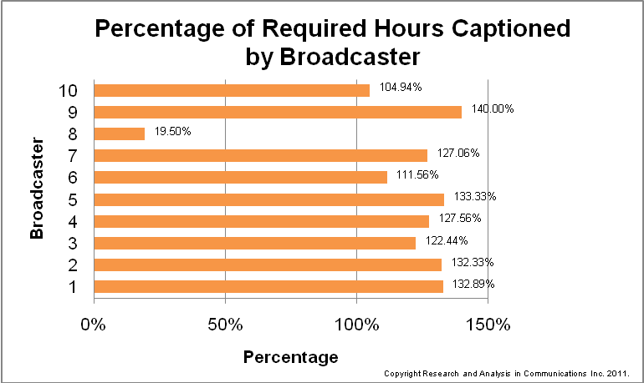

Description of Figure 1: This is a bar chart titled “Percentage of Required Hours Captioned by Broadcaster”. The chart compares 10 Broadcasters, labelled as Broadcaster 1 through 10 for anonymity purposes. The labels are consistent throughout this report. The data is summarized in the following table.

 | Percentage
Broadcaster 1 | 132.89%
Broadcaster 2 | 132.33%
Broadcaster 3 | 122.44%
Broadcaster 4 | 127.56%
Broadcaster 5 | 133.33%
Broadcaster 6 | 111.56%
Broadcaster 7 | 127.06%
Broadcaster 8 | 19.5%
Broadcaster 9 | 140%
Broadcaster 10 | 104.94%
Percentages are based on an 18-hour broadcast day (see footnote on p.10). Percentages over 100% therefore indicate more than 18 hours of captioning and in the period between midnight and 6 am.

Broadcasters' provision of CC content is shown in the graph (fig.1) and is an indicator of success in the quantitative provision of captioning. At this time all broadcasters are in compliance with their CRTC conditions of licence, in fact all exceeded the requirements. Going forward the CRTC Decision 2009-430 measuring quality for the purposes of developing a standard will require further efforts from the broadcasters to avoid non-compliance.

It is important to note 100% of the time, if a program was captioned, it was not provided as such on the broadcaster’s website – a non-regulated content distribution undertaking.

Fig. 2)

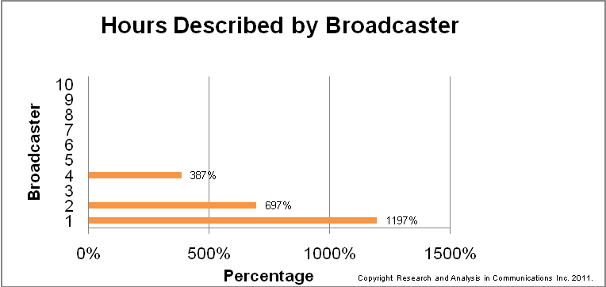

Description of Figure 2: This is a bar chart titled “Hours Described by Broadcaster”. The chart compares 10 Broadcasters, labelled as Broadcaster 1 through 10 for anonymity purposes. The labels are consistent throughout this report. The data is summarized in the following table.

 | Percentage
Broadcaster 1 | 1,197%
Broadcaster 2 | 697%
Broadcaster 3 | 0
Broadcaster 4 | 387%
Broadcaster 5 | 0
Broadcaster 6 | 0
Broadcaster 7 | 0
Broadcaster 8 | 0
Broadcaster 9 | 0
Broadcaster 10 | 0

This graph reflects the percentage of required hours of description monitored for each broadcaster. Surplus percentages indicate an excess over and above the broadcasters requirements, and thus represent the percentage of those requirements that were met.

Our data indicates that broadcasters are either very committed to the provision of DV or show no interest whatsoever. While the most committed provide from 15 to over 50 hours per 168 hours of programming in a broadcast week, others provide none. This an indicator of how high the bar can be set with respect to condition of license, as well as an indicator of need for on-going monitoring for compliance concerning DV. It is worth noting that as in other areas of accessibility, unless it is regulated and monitored DV will not increase or be complied to.

It is important to note 100% of the time, if a program was described, it was not provided as such on the broadcaster’s web site – a non-regulated content distribution undertaking.

Fig. 3)

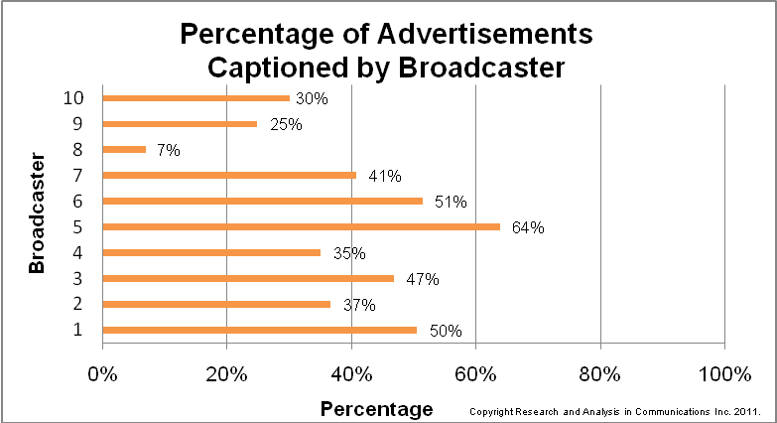

Description of Figure 3: This is a bar chart titled “Percentage of Advertisements Captioned by Broadcaster”. The chart compares 10 Broadcasters, labelled as Broadcaster 1 through 10 for anonymity purposes. The labels are consistent throughout this report. The data is summarized in the following table.

 | Percentage
Broadcaster 1 | 50%
Broadcaster 2 | 37%
Broadcaster 3 | 47%
Broadcaster 4 | 35%
Broadcaster 5 | 64%
Broadcaster 6 | 51%
Broadcaster 7 | 41%
Broadcaster 8 | 7%
Broadcaster 9 | 25%
Broadcaster 10 | 30%

Incorporating the highest and lowest values together as a weighted average (34%), the average for all broadcasters was 38.8% of ads captioned.

Currently, there is no CRTC requirement to caption advertisements. However, in CRTC 2009-430 there is a requirement for, upon broadcaster license renewal, 100% by the third year of license or by 2016.

One broadcaster is already captioning 100% of its advertisements and PSAs demonstrating that it is now possible to do so.

It is also notable that there were no described commercials and therefore, no graph was created for amount of advertisements described.

Fig. 4)

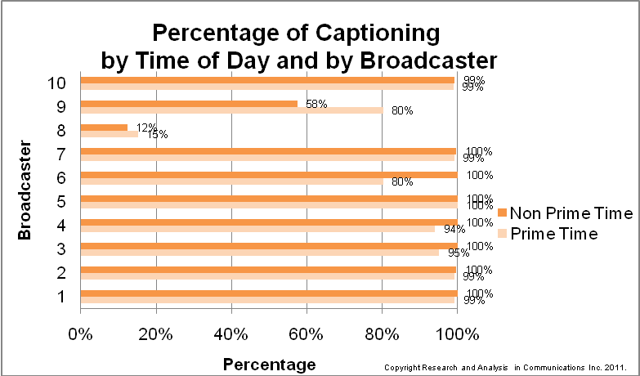

Description of Figure 4: This is a clustered bar chart titled “Percentage of Captioning by Time of Day and by Broadcaster”. The chart compares 10 Broadcasters, labelled as Broadcaster 1 through 10 for anonymity purposes. The labels are consistent throughout this report. The data is summarized in the following table.

 | Prime Time | Non Prime Time
Broadcaster 1 | 99% | 100%
Broadcaster 2 | 99% | 100%
Broadcaster 3 | 95% | 100%
Broadcaster 4 | 94% | 100%
Broadcaster 5 | 100% | 100%
Broadcaster 6 | 80% | 100%
Broadcaster 7 | 99% | 100%
Broadcaster 8 | 15% | 12%
Broadcaster 9 | 80% | 58%
Broadcaster 10 | 99% | 99%

Our figures reflecting captioning by time of day show only two notable variations in CC provision between prime time and non prime time hours out of ten broadcasters. The first being one of 19.66% more provision in the non prime time hours and in the second 22.76% less provision during the same time.

Fig. 5)

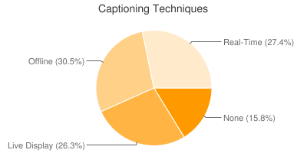

Copyright Research and Analysis in Communications Inc. 2011.

Description of Figure 5: This is a pie chart titled “Captioning Techniques”. The data is summarized in the following table.

None | 15.8%
Live Display | 26.3%
Real-Time | 27.4%
Offline | 30.5%

Leaving aside the 15.8% of programming without captions, offline, real-time and live-display CC are roughly evenly divided, with offline captioning the most widely-used at 30.5%, followed by live-display at 26.3% and the more error-prone real-time captioning production technique at 27.4%. Live-display, a function of both real-time and off-line can be found in both live and post-production environments in the form of roll-up captions.

Fig. 6)
Captioning Technique by Program Category

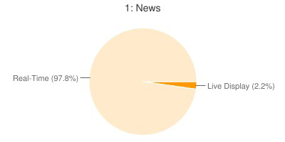
Copyright Research and Analysis in Communications Inc. 2011.

Description of Figure 6: Figure 6 is a set of pie charts. The set is titled “Captioning Technique by Program Category”. The first pie chart is titled “1: News”. The data is summarized in the following table.

Live Display | 2.2%
Real-Time | 97.8%

In the original Monitor, live-display method for captioning news was singularly the biggest challenge to captioning quality, with only scripted portions of news programming being captioned. Live-display continues to be used as a function of real-time, but not as a stand-alone approach.

Given news programming is produced by the broadcaster, captioning will be purchased directly by them whereas other programming will more likely arrive already captioned.

News also covers categories 2a Analysis and interpretation and 3. Reporting

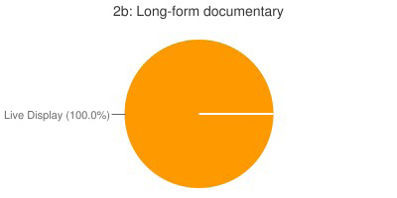
Copyright Research and Analysis in Communications Inc. 2011.

Description of next pie chart: This pie chart is titled “2b: Long-form documentary”. The data is summarized in the following table.

Live Display | 100%

While a documentary is not live and therefore, should theoretically have pop-on captions, some have argued that because it is live-looking, (i.e., gives the appearance and is consistent with the 'live' aesthetic of live programming) roll-up presentation is more appropriate and consistent with the genre of the content. The graph above indicates this would be the position of content producers and possibly broadcasters, (depending on was who responsible for captioning). This will be tested in the qualitative phase.

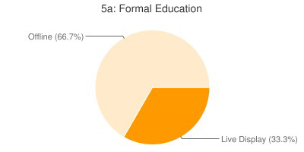
Copyright Research and Analysis in Communications Inc. 2011.

Description of next pie chart: This pie chart is titled “5a: Formal Education”. The data is summarized in the following table.

Live Display | 33.3%
Offline | 66.7%

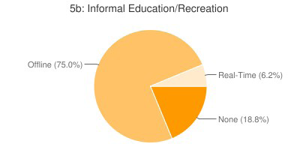

Copyright Research and Analysis in Communications Inc. 2011.

Description of next pie chart: This pie chart is titled “5b: Informal Education/Recreation”. The data is summarized in the following table.

Real-Time | 6.2%
None | 18.8%
Offline | 75%
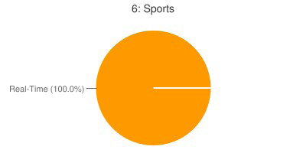
Copyright Research and Analysis in Communications Inc. 2011.

Description of next pie chart: This pie chart is titled “6: Sports”. The data is summarized in the following table.

Real-Time | 100%

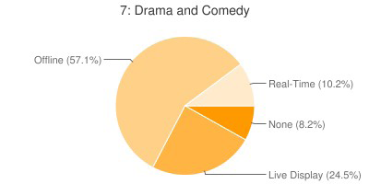
Copyright Research and Analysis in Communications Inc. 2011.

Description of next pie chart: This pie chart is titled “7: Drama and Comedy”. The data is summarized in the following table.

None | 8.2%
Real-Time | 10.2%
Live Display | 24.5%
Offline | 57.1%

This represents the largest category for acquired content.

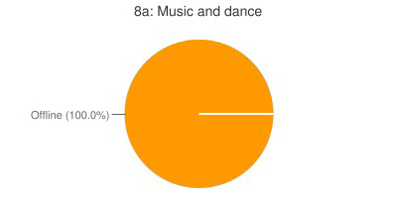
Copyright Research and Analysis in Communications Inc. 2011.

Description of next pie chart: This pie chart is titled “8a: Music and dance”. The data is summarized in the following table.

Offline | 100%

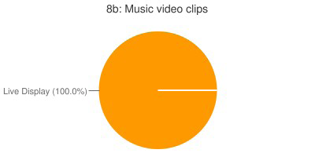
Copyright Research and Analysis in Communications Inc. 2011.

Description of next pie chart: This pie chart is titled “8b: Music video clips”. The data is summarized in the following table.

Live Display | 100%

Because 8b. is not live, it should, under current practice, have pop-on captions. However, the above graph is an indicator that consistent with live looking programming roll-up is appropriate. This will be tested in the qualitative phase.

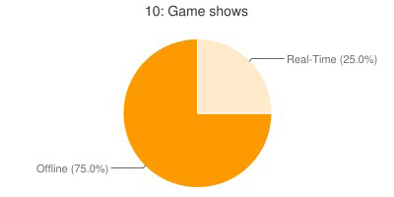
Copyright Research and Analysis in Communications Inc. 2011.

Description of next pie chart: This pie chart is titled “10: Game shows”. The data is summarized in the following table.

Real-Time | 25%
Offline | 75%

Over and over again we see, in programming that is live-looking, the use of roll-up captioning as a presentation style even when the program is produced in advance. This is likely due to the ability to produce the captioning more quickly and at a lower cost. However there may also be an argument for consistency of presentation style in live and non-live-looking content and this will be tested.

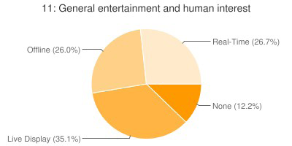
Copyright Research and Analysis in Communications Inc. 2011.

Description of next pie chart: This pie chart is titled “11 General entertainment and human interest”. The data is summarized in the following table.

None | 12.2%
Offline | 26%
Real-Time | 26.7%
Live Display | 35.1%

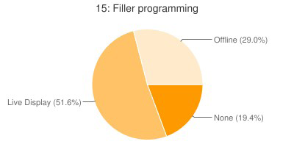
Copyright Research and Analysis in Communications Inc. 2011.

Description of next pie chart: This pie chart is titled “15: Filler programming”. The data is summarized in the following table.

None | 19.4%
Offline | 29%
Live Display | 51.6%
Fig. 7)

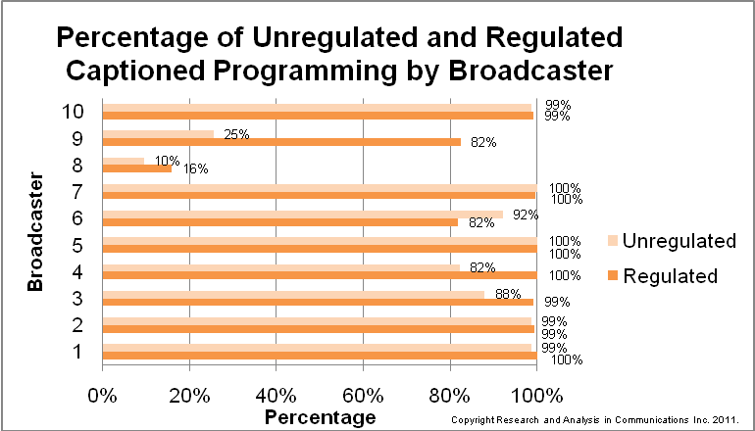

Description of Figure 7: This is a clustered bar chart titled “Percentage of Unregulated and Regulated Captioned Programming by Broadcaster”. The chart compares 10 Broadcasters, labelled as Broadcaster 1 through 10 for anonymity purposes. The labels are consistent throughout this report. The data is summarized in the following table.

 | Regulated | Unregulated
Broadcaster 1 | 100% | 99%
Broadcaster 2 | 99% | 99%
Broadcaster 3 | 99% | 88%
Broadcaster 4 | 100% | 82%
Broadcaster 5 | 100% | 100%
Broadcaster 6 | 82% | 92%
Broadcaster 7 | 100% | 100%
Broadcaster 8 | 16% | 10%
Broadcaster 9 | 82% | 25%
Broadcaster 10 | 99% | 99%

This graph shows the percentage of regulated vs. unregulated captioned content, according to the CRTC definition of a broadcast day. Most broadcasters' CC provision was roughly even between regulated and unregulated hours of the broadcast day, with the exception of three broadcasters with less captioning during unregulated hours, and one broadcaster with more captioning during unregulated hours.

Fig. 8)

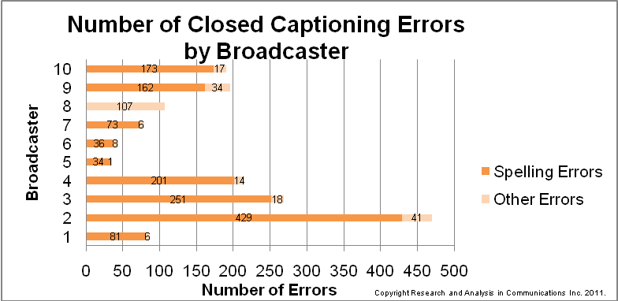

Description of Figure 8: This is a stacked bar chart titled “Number of Closed Captioning Errors by Broadcaster”. The chart compares 10 Broadcasters, labelled as Broadcaster 1 through 10 for anonymity purposes. The labels are consistent throughout this report. The data is summarized in the following table.

 | Spelling Errors | Other Errors | Total Errors
Broadcaster 1 | 81 | 6 | 87
Broadcaster 2 | 429 | 41 | 470
Broadcaster 3 | 251 | 18 | 269
Broadcaster 4 | 201 | 14 | 215
Broadcaster 5 | 34 | 1 | 35
Broadcaster 6 | 36 | 8 | 44
Broadcaster 7 | 73 | 6 | 79
Broadcaster 8 | 0 | 107 | 107
Broadcaster 9 | 162 | 34 | 196
Broadcaster 10 | 173 | 17 | 190

Spelling errors are the single most frequent type of error. Spelling errors include misspelled words, proper names and punctuation that obscured the meaning of the caption. Other errors were either non-captioned segments or instances when captions obscured important onscreen information.

Fig. 9)

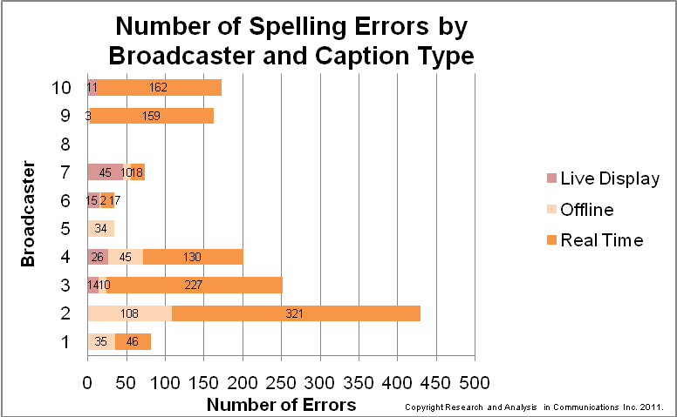

Description of Figure 9: This is a stacked bar chart titled “Number of Spelling Errors by Broadcaster and Caption Type”. The chart compares 10 Broadcasters, labelled as Broadcaster 1 through 10 for anonymity purposes. The labels are consistent throughout this report. The data is summarized in the following table.

 | Live Display | Offline | Real-Time | Total Spelling Errors
Broadcaster 1 | 0 | 35 | 46 | 81
Broadcaster 2 | 0 | 108 | 321 | 429
Broadcaster 3 | 14 | 10 | 227 | 251
Broadcaster 4 | 26 | 45 | 130 | 201
Broadcaster 5 | 0 | 34 | 0 | 34
Broadcaster 6 | 15 | 2 | 17 | 34
Broadcaster 7 | 45 | 10 | 18 | 73
Broadcaster 8 | 0 | 0 | 0 | 0
Broadcaster 9 | 0 | 3 | 159 | 162
Broadcaster 10 | 11 | 0 | 162 | 173

Orthographic errors in captioning occurred across the board for all broadcasters sampled, and with a high degree of variation among them. The value which appears to be missing in the case of #8 corresponds with the very limited amount of captioning provided and therefore monitored (see fig.1).

The incidence of captioning errors reported by the Accessibility Lens shows the vast majority of spelling errors occur in real-time captioned programming with offline captioning the second most likely source of error, followed by live-display. Thus, for instance, in the program category "news” where shows are overwhelmingly captioned in real-time (97.8%) over live-display (2.2%)―the preferred captioning technique is the one most likely to produce captioning errors for viewers (see fig.6 Captioning Technique by program category; 1:News). Where offline captioning for prerecorded programming is an option other techniques were used but they also had high rates of error, with religious programming having the highest rate (63.6%) of non-closed captioned programming. Similarly, whereas "drama and comedy" show a balance of all captioning techniques and a preference for live-display over real-time, a deficiency of CC (8.2%) indicates the need for more attention to technical problems and lapses contributing to error.

The propensity for error per captioning technique (fig.9, Spelling errors by caption technique) is significant not only in view of the use of the various techniques but also when considered, in light of program category, where captioning technique varies widely, and also in light of the incidence of error by captioning technique.

Fig. 10)

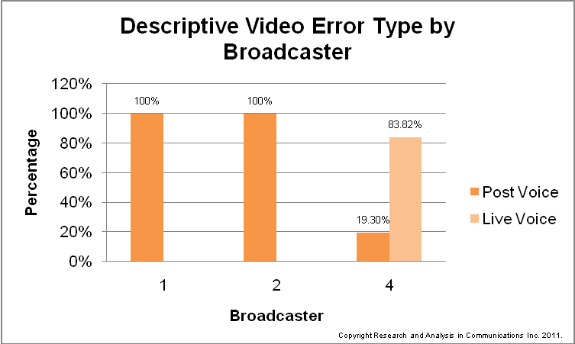

Description of Figure 10: This is a clustered column chart titled “Descriptive Video Error Type by Broadcaster”. The chart compares 3 Broadcasters, labelled as Broadcaster 1, 2 and 4 for anonymity purposes. The data is summarized in the following table.

 | Post Voice | Live Voice
Broadcaster 1 | 100% | 0%
Broadcaster 2 | 100% | 0%
Broadcaster 4 | 19.3% | 83.82%

Given the quality of DV is much more subjective that CC, it was decided for the purpose of measuring the quantity of errors, only technical errors could be counted. Currently, Media Access Canada, with the support of Analysis and Research in Communications as project manager and writer, along with Ryerson Univerisy and CRIM, is preparing a Best Practices Manual for Production and Presentation of Descriptive Video for both French and English. This manual/chapter is being produced in collaboration with industry experts and DV users. It will be published as part of the Accessible Content Best Practices Guide for Digital Environments.

Further research into user preferences will be conducted during the qualitative phase of this project and reported on in January 2012.

The technical quality of DV content monitored, therefore, was generally very high, with very few instances of errors (5 total) such as loss of video description (in which no DV can be heard during a program otherwise fully described). Figure 10 shows the ratio of post-voice and live-voice DV errors as a percentage of total error duration. Though in one broadcaster the instance of live-voice errors (of dropped or missing descriptions) was far greater than post-voice, a lack of live-voice content in the other broadcasters hinders any comparison to verify this as a pattern.

Fig. 11)

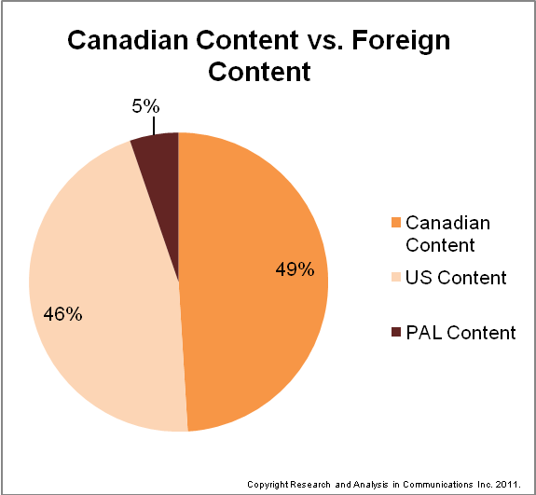

Description of Figure 11: This is a pie chart titled “Canadian Content vs. Foreign Content”. The data is summarized in the following table.

PAL Content | 5%
US Content | 46%
Canadian Content | 49%

It is noteworthy, that a Canadian broadcaster has no control over the quality of acquired captions. The Twenty-First Century Communications and Video Accessibility Act of 2010, a U.S. law will regulate the quality and quantity of accessible content over time.

Therefore, the Canadian broadcaster can only be responsible for 49% of the quality of both Captioning and Description. From this 49%, CMF funded programming, will also cover costs for captioning and description if included in the production budget. Therefore, broadcasters may want to ensure their licensing agreements with independent broadcasters require delivery of a captioned and described master.

Fig 12)

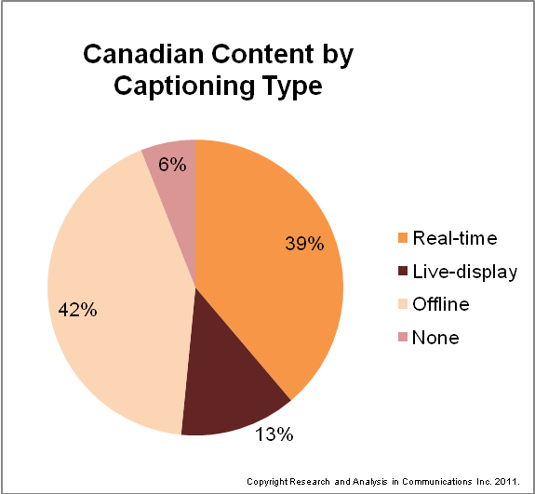

Description of Figure 12: This is a pie chart titled “Canadian Content by Captioning Type”. The data is summarized in the following table.

None | 6%
Live-display | 13%
Real-time | 39%
Offline | 42%
Currently there is a directive from Canadian Heritage to ensuring captioning of any program receiving CMF funds, but no directive from Canadian Heritage for DV, although they will pay for descriptions in the producer includes the cost in their budget. CMF currently has no policy in place for cost control or quality associated with the funds it provides for CC and DV.

Real-time captioning, which represents the bulk of captioning over which the broadcaster has control, is virtually always sourced from a real-time captioning firm. This would indicate, as suggested elsewhere, that standards should focus on procurement rather prescribing prescribe best practice.

Fig. 13)

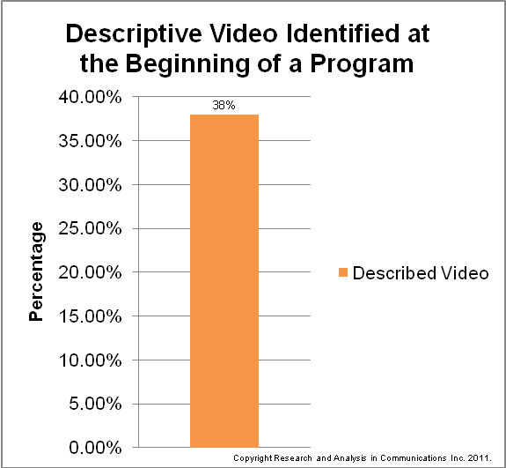

Description of Figure 13: This is a column chart titled “Descriptive Video Identified at the Beginning of a Program”. The data is summarized in the following table.

Described Video | 38%

At the time of publication, a review of captioning identification was being done. Given captioning is 100%, the need for identification is not critical. However, given the requirement for DV is approximately 3% of a broadcast week for conventional broadcasters, that only 38% of the 3% those programs were identified as DV is notable.

Conclusion

This project is a follow-on to the original Monitor study, which was done in 1992 to look at closed captioning available in Canada. For the Monitor 2 study, Analysis and Research in Communications Inc., sampled 1800 hours of content across the Canadian broadcasting system, looking at both DV and CC. A total of ten English broadcasters were included, selected to represent all ownership groups (Shaw, BCE, etc.) Software called The Accessibility Lens was developed to track the broadcast content for Monitor 2.

Most of the broadcasters were found to offer CC for more than 100% of their broadcast day, with the day being defined as the period from 06:00 to midnight. All were in compliance of their CRTC conditions of licence, (COL). Since CC of commercials, PSAs, etc. is not a COL, these media did not factor into the quantitative measurement. Each of the 10 broadcasters was monitored for a full day to gather the captioning data.

With regard to DV, all 10 broadcasters were monitored for a full week because CRTC COL is over a broadcast week (currently set at four hours per 126-hour week for most conventional broadcasters.) Three of the 10 exceeded the amount of DV content required by their broadcast licences, with one providing 1197% of their requirement, a second providing 694% and the third providing 387% of their requirement. None of the other seven broadcasters was found to provide any DV content. This points to the need for increased regulation and compliance measurement through on-going monitoring to ensure future COL’s are complied to.

Error rates were also monitored both for CC and DV. In captioning, the majority of errors reported were spelling errors, and this was true both of live captioned content and content where the captions were added in post-production. This is a matter of concern to people who use captions to follow a program, as it illustrates the need to develop quality control guidelines. Providing captions that are inaccurate or as is sometimes the case, unreadable, undermines access for deaf and hard of hearing viewers.

Live CC using the stenographer-based Real-time captioning had most errors, (see fig. 9) a captioning style represented in the majority of Canadian content that the broadcaster commissions. Real-time captioning is provided by captioning companies and not by in-house staff at the broadcast facility. This would indicate that a procurement-based standard--focused on regulating captioning services to ensure captions are procured by broadcasters from licensed, quality-assured captioning houses--rather than a prescriptive standard stipulating how captioning ought to be produced, would ultimately have a greater impact on quality improvements.

The majority of errors reported in DV content were found in live description (82%) as opposed to post-voice (post-production) which was accounted for 18% of errors. MAC’s Descriptive Video Production and Presentation Best Practices sub-committee is currently studying CTV’s “Dancing with the Stars” live description and is expected to publish in September 2012.

Unless producing in house, broadcasters don’t have control over captioning or description quality for acquired programming (from foreign sources, for example) or for programming produced by independent producers unless control of CC and/or DV is specified in contracts. Monitor 2 looks at what the broadcaster can and cannot control and what aspects of captioning or description actually constitute out of pocket expenses for the broadcaster.

What emerges from the research is what a broadcaster can control with respect to captioning and DV quality, with is who they contract to. Right now, the Real-time captioning industry is reasonably robust enough to introduce a procurement standard that would require the broadcaster to ensure their contracts and RFP’s required the captioning production houses demonstrate a “broadcast quality” that was reflected in a industry and accessibility community supported best practices production and presentation manual. A manual that would change over time to reflect innovation in CC and DV.

The expansion of content distribution platforms to un-regulated environments, but which the broadcasters have control is, 100% of the time not CC or DV. This is a strong indicator, both of the need for continued regulation and new regulation for these emerging distribution platforms which now make a broadcaster also a distributor of content.

Expected in an large research undertaking over time, priorities change and the need for additional research presents itself. One example of this was the lag research and resulting data found in appendix 2. However, because the funds were very limited and finite, not all emerging industry priorities could be addressed. For example, there is a need for an in-depth study into tracking accessible content across programming services. However, this is not in scope of this project and requires additional funding.

Finally there is a need for a similar Monitor 1 for the French broadcasting market, as well as Telecom so that industry stakeholders, regulators and accessibility community can make informed decisions. It is also necessary for future business modelling to limit the communications spend while maximizing revenues from accessible content. It is also important to note there has never been a Monitor of French broadcasting. Regardless, The Accessibility Lens was designed to sample both French and English broadcasting.

Next Steps

The publication of this report marks the completion of Phase 1 of the research, moving into Phase 2, Quality Analysis. While this report has touched on quantity of accessible content in Canadian broadcasting, there is a wealth of data collected and stored in the Accessibility Lens not reported here, but to be used in the qualitative analysis. We have begun this process by identifying a methodology for examining subjective standpoints on aspects of the quality and style of accessible broadcast content, and are proceeding with focus-group and individual studies for the purposes of gaining an understanding of acceptable quality, preferred presentation style, preferred sourcing of accessible content and such related issues.

The objective of this next phase of analysis is to inform us of baseline presentation quality markers, working back to user interface styles, i.e. pop-on and roll-up, and suggesting possible production improvements. The focus research will therefore involve the creation of environments where we can gather user feedback and correlate, via factor analysis, subjects’ statements and concerns to current production styles and techniques. By identifying patterns and frequency among factors we will identify subjects’ presentation and viewing priorities and arrive at a renewed value system for best practices through which standards can be informed.

We therefore intend to apply the factor analysis called “Q-Method” in order to gauge stakeholders' positions on matters relating to the provision of accessible broadcast and web-content in Canada. As envisaged by the methodology, the Q-method applied for the Monitor 2 study will use a variety of methods including web-forums, surveys and interviews to compile what is referred to as a “concourse” of opinions and assertions related to the issue and representing a wide spectrum of standpoints and perspectives. Using this concourse, surveys with subjects are conducted in which statements in the total concourse are organized, in what is called a “Q-sort,” by the subject according to Likert scales of agreement or disagreement. Following the intended sample-size of Q-sorts involving stakeholder subjects, the data for each and all subjects can be subjected to various factor analyses in order to determine the frequency and degree of certain statements of opinion and their relation to any other factor in the dataset. With such a comprehensive factor analysis we intend to arrive at general profiles for subjective standpoints on accessible content quality and production styles that will greatly inform standards and best practices. Consultation with Q-method researchers for the qualitative phase of the Monitor 2 is ongoing and methodology is being prepared for academic peer review.

Also next is the publication of the English DV Production and Presentation section of the Accessible Content Best Practices Guide for Digital Environments. This best practices guide, will reflect user preferences, styles and approaches to both CC and DV. In consultation with stakeholders across the country we will develop a synthesis of their comments on such aspects as the type and quality of CC and DV. Stakeholders include broadcasters, producers and users. A Best Practices guide is expected to be published this Fall and the final project report will come in spring 2012.

Appendix

1. Canadian Media Fund Accessibility Policy

From: Neal McDougall [mailto:NMcDougall@ctf-fct.ca]
Sent: Friday, October 23, 2009 1:24 PM
To: Beverley Milligan
Subject: RE: Accessible Content

Hi Beverly,

Our current guidelines can be found on our website here:
http://www.ctf-fct.ca/producers_home_en.html

With regards to our policies that directly relate to accessibility issues, most relevant is probably the following from section 3.2.4 of our production guidelines (i.e. BPE, French-language Projects Outside Quebec, and Aboriginal-language Projects):

An Eligible Project must meet the following criteria:

* It is closed-captioned if it contains narrative, dialogue or lyrics. Exceptions may be permitted for projects targeted to children under the age of five, projects in Aboriginal languages that do not use the Roman alphabet, and live-to-air productions;

This requirement also flows through to the broadcaster, who has the following obligation as stated at section 3.2.5 of the same guidelines:

A broadcast licence agreement containing an Eligible Licence Fee must include an unqualified commitment by the broadcaster to broadcast the production closed captioned, in peak viewing hours, within 18 months of completion and delivery of the production. [Emphasis added]

The costs associated with closed captioning may be included in the production budget of the project and are thus supported by the CTF through its financing to the overall production costs.

We have been also been asked about our approach to video description.
Unlike closed captioning, the CTF has no requirement that video description be a part of the production in order for that production to access the CTF.
However, like closed captioning, we will support the costs associated with described video as part of the overall production costs if video description is a contractual requirement by the broadcaster. This fact is not stated anywhere in our guidelines, but it is our practice.

I hope that helps.

Neal McDougall

Policy Analyst | Analyste des politiques
Tel / Tél. 416 214 4457 | Fax / Téléc. 416 214 4457

2. Captioning Lag

i) Methodology
Real-time captioners use a computerized system based on the stenographic shorthand used by court reporters. A real-time captioner, someone who has been trained to transcribe speech to text using a steno machine, listens to a program's dialogue as it is being broadcast and enters the words phonetically in stenographic shorthand code. The steno machine is connected to computer containing software that translates stenographic shorthand into words using standard spellings and then converts them to a caption format. The caption data is transmitted instantaneously via modem to the master control at the network. There, the caption data is inserted into Line 21 of the television signal through a smart encoder. Since the real-time captioner cannot transcribe a word until it is spoken, real-time captions always lag slightly behind the audio, generally by about two to three seconds.

To determine if additional captioning lag existed and if so, to what extent, an algorithm was developed as an adjunct to the Accessibility Lens. It allowed a researcher to code a selected piece of content at 15-second intervals, recording timecodes at both audio and caption events in order to measure their synchronization and the duration of any lag. Commercials, PSAs and live-display were eliminated from the data where possible. A selection of real-time captioned programming was selected from among the available samples and the length of this sample was arbitrarily selected as either one half hour or a full hour depending on the program. It should be noted that the number of samples for any given time will vary according to the amount of commercial segments, the type of programming and the frequency of audio/captioned segments.

ii) Caption Lag Data

The charts show the caption lag duration times over the course of the monitored time (1 hour or half an hour). The Y-axis values correspond to the length of duration, while the X-values represent the sample (numbered) on which it was taken. It should be noted that there are some breaks in the sample times (some are longer than 15 seconds) which correspond to either advertising segments (not monitored) or otherwise non-captioned segments (if spoken words otherwise appear on the screen and so are not captioned, as when a news anchor reads off letters from viewers).

Sample 1
Average duration6.02s
Median duration5.59s
Standard deviation1.51s

Sample 2
Average duration4.84s
Median duration4.68s
Standard deviation1.42s

Sample 3
Average duration4.69s
Median duration4.79s
Standard deviation1.82s

Average duration6.39s
Median duration5.91s
Standard deviation1.65s
Sample 4

Sample 5
Average duration2.57s
Median duration6.85s
Standard deviation4.1s

Sample 6
Average duration2.33s
Median duration3.26s
Standard deviation1.10s

Sample 7
Average duration6.98s
Median duration6.60s
Standard deviation1.41s

Sample 8
Average duration8.23s
Median duration10.82s
Standard deviation3.8s

The second examination, which looked at causes of captioning lag and dropped captions, was outsourced to a real-time captioning facility where, using a direct audio feed, they captioned a piece of content and measured lag on the return satellite and cable signals. It was determined that while lag did occur, the distance, while consistent, did vary between distributor.

The conclusions from this study indicate that assuming direct audio feed captioning lag comes primarily from two sources: the captioner’s skill and the BDU.

The latter must undergo further study and is not in scope of this Monitor Study. However, with respect to the bulk of the lag problem—which rests with the captioner in the form of dropped captions and lag of as much as 17 seconds, it is possible that a procurement standard focused on broadcast quality captions could have a stronger impact on quality than a standard focused on post examination of lag time and dropped captions.

Possible solutions to remedy captioning lag after 3 seconds:
The Synchronization Solution 1 – Audio Coupler
Delays are increased depending upon the means by which the captioner receives the audio of the program. The audio delay to the captioner can be removed by the use of audio coupler at the program origination source such as the broadcaster’s master control.
The Synchronization Solution 2 – 2-Second Digital Delay
Caption synchronization could be improved significantly through the use of a 2 second digital delay. The captioner would listen to a pre-delayed audio feed on an audio coupler. Transmission of the captions on the 2-second delayed broadcast would permit the captions to be closer to synchronization.

The Synchronization Solution 3 – Procurement
Even with the installation of an audio coupler or a 2 second delay, the captioning production company/captioner, must be properly qualified to provide the service. Likely the easiest solution would be a standard requiring broadcasters to provide and require real-time captioners to have a direct audio feed through an audio coupler or some other technology, and that the commissioning ofreal-time captioning, or any captioning be to ONLY broadcast quality certified accessible content production houses.

3. Glossary of Terms used

Audio Description | Audio description uses a program host or announcer to provide a basic voice-over, reading text and describing graphics that appear on the screen. AD is often used for newscasts, weather reports, sports scores or financial data, and is best suited to live, information-based programming.
Voice Recognition | The technology that allows a computer to identify the words that a person speaks into a microphone or telephone and convert it to written text.
Closed captions | Captions that can only appear with the use of a decoder. The decoder may be either attached to a TV or built into TV's made in the US after July 1993. Closed captioning allows caption users to enjoy the same broadcast and recorded video materials that other television viewers enjoy. Closed-caption information is carried in Line 21 of the vertical blanking interval of the television signal. (NCI)
Decoder | Also called a telecation adapter, a decoder is an electronic device that can display closed captions encoded in line 21 of television programs. Since July 1, 1993, all television sets with screens 13 inches or larger manufactured for sale in the United States must have a built-in decoder chip – Television Chip Decoder Circuitry Act of 1993.
Described video (DV) | Descriptive Video is also called video description or described narrative. DV is a narrated description of a program's main visual elements, such as settings, costumes, or body language. The description is added during pauses in dialogue, and enables people to form a mental picture of the program. It works best for pre-recorded programs, such as dramas and documentaries.
Electronic newsroom captioning | Captions are conveyed from the teleprompter being read by those on-screen
Live display | Live-display captioning is used when an accurate script and/or videotape is available prior to program telecast. Captions are prepared in advance and stored on a computer disk. As the program is telecast, a captioner pushes a button on the captioning system to display each caption. The roll-up captions appear line-by-line and are synchronized with the program audio as closely as possible.  Live Display is a function of Real-time captioning and may be used from time to time in “live looking” television programs as a function of Off-line captioning.
On-line – live captioning | Captioning that is provided when the program originates, using “real-time,” “live-display” or a combination of both, using roll-up.
Off-line – post-production captions | The process of adding captions to pre-recorded video content, in which captioners listen to the video and transcribe the dialogue, breaking the transcript into captions on the screen. These captions are timecoded and encoded into the video signal.  Off-line captioning is usually pop-on, however, live display is also a function of off-line software and, therefore, roll-up is used in post-production programming.
Pop-on captions | Several lines of captioned text appear or ‘pop’ on to the screen, and disappear or ‘pop’ off after several seconds. More than one pop-on caption may appear on the screen simultaneously. Pop-on captions are often used as a way to identify who is speaking.
Real-time captioning | Method of captioning in which captions are simultaneously prepared and transmitted at the time of origination by specially trained real-time captioners using a stenotype machine.
Roll-up captions | Several lines of captioned text appear to scroll: as the first line ‘rolls’ away, a new line appears at the bottom. Roll-up captions typically have a steady rate of scroll, but captioners may alter the speed to maintain pace with the program’s audio elements.
Secondary Audio Program (SAP) | Is an additional audio channel that can be received by all viewers with stereo television sets in markets where SAP is available. It can be used for any audio signal but is most often used to transmit a secondary language for English-language programming.

There are two means to pass through described video. One is to embed the audio track containing the descriptions with the television program's video and primary audio track. This approach, which is known as "embedded described video," requires a means to select the audio track that provides the descriptions. A person with a visual impairment turns on the described video to hear the descriptions. Alternatively, the audio track containing described video can be distributed together with the original audio and video on a dedicated channel. This is known as "open format described video." Under this approach, described video is always turned on and can be heard by all tuning into the program. (CRTC 2009-48)
The Monitor Project, CCDA 1993
http://www.crtc.gc.ca/eng/archive/1995/pb95-48.htm
http://www.crtc.gc.ca/eng/archive/2009/2009-430.htm
"Broadcast day" means the period of up to 18 consecutive hours, beginning each day not earlier than six o'clock in the morning and ending not later than one o'clock in the morning of the following day, as selected by the licensee. Broadcasting Notice CRTC 2007-54
CRTC broadcast day is 6 am to 12 am.
While it is recognized that garbled text is usually a result of technical error and not captioner error it was still considered timecode not captioned for the purpose of quantifying the amount of captioning.
Only one hour of Audio Description was identified and for the purposes of this report was coded as DV
Advertisements also included PSA’s, station identification and promo’s
It is important to note that at the time of publication, the broadcast logs were unavailable for the periods monitored. Therefore, the reported program category could not be correlated to what was reported on the broadcast log and thus may vary slightly from actual. It was decided while there may be a conflict between the monitors' program category with the broadcast log, these differences could be corrected at a later date, but would not fundamentally impact the results as live content and post-produced content are relatively straightforward.
See above footnote.
http://www.coataccess.org/node/4623
Delays are increased depending upon the means by which the captioner receives the audio of the program. The audio delay to the captioner can be eliminated by the use of audio coupler at the program origination source such as the broadcaster’s master control.
Many broadcasters have already installed audio coupler, CTV being one of them

